A5 – Compose DB Pokémon

Esraa Abdelmoein

2025-10-3

My GitHub URL is: [Mobile-Application-Android/Assignment05_Pokemon at assignment4 · EsraaAbdelmoein/Mobile-Application-Android](https://github.com/EsraaAbdelmoein/Mobile-Application-Android/tree/assignment4/Assignment05_Pokemon)

# Section 1: Change the DB to list Pokémon characters

So here we will Updated Data Model for Pokémon

DataModel.java

Change: Converted from generic car model → Pokémon entity.

Old fields:

private String str_col;

private Integer num_col;

to:

private long id;

private int number;

private String name;

private int powerLevel;

private String description;

private int accessCount;

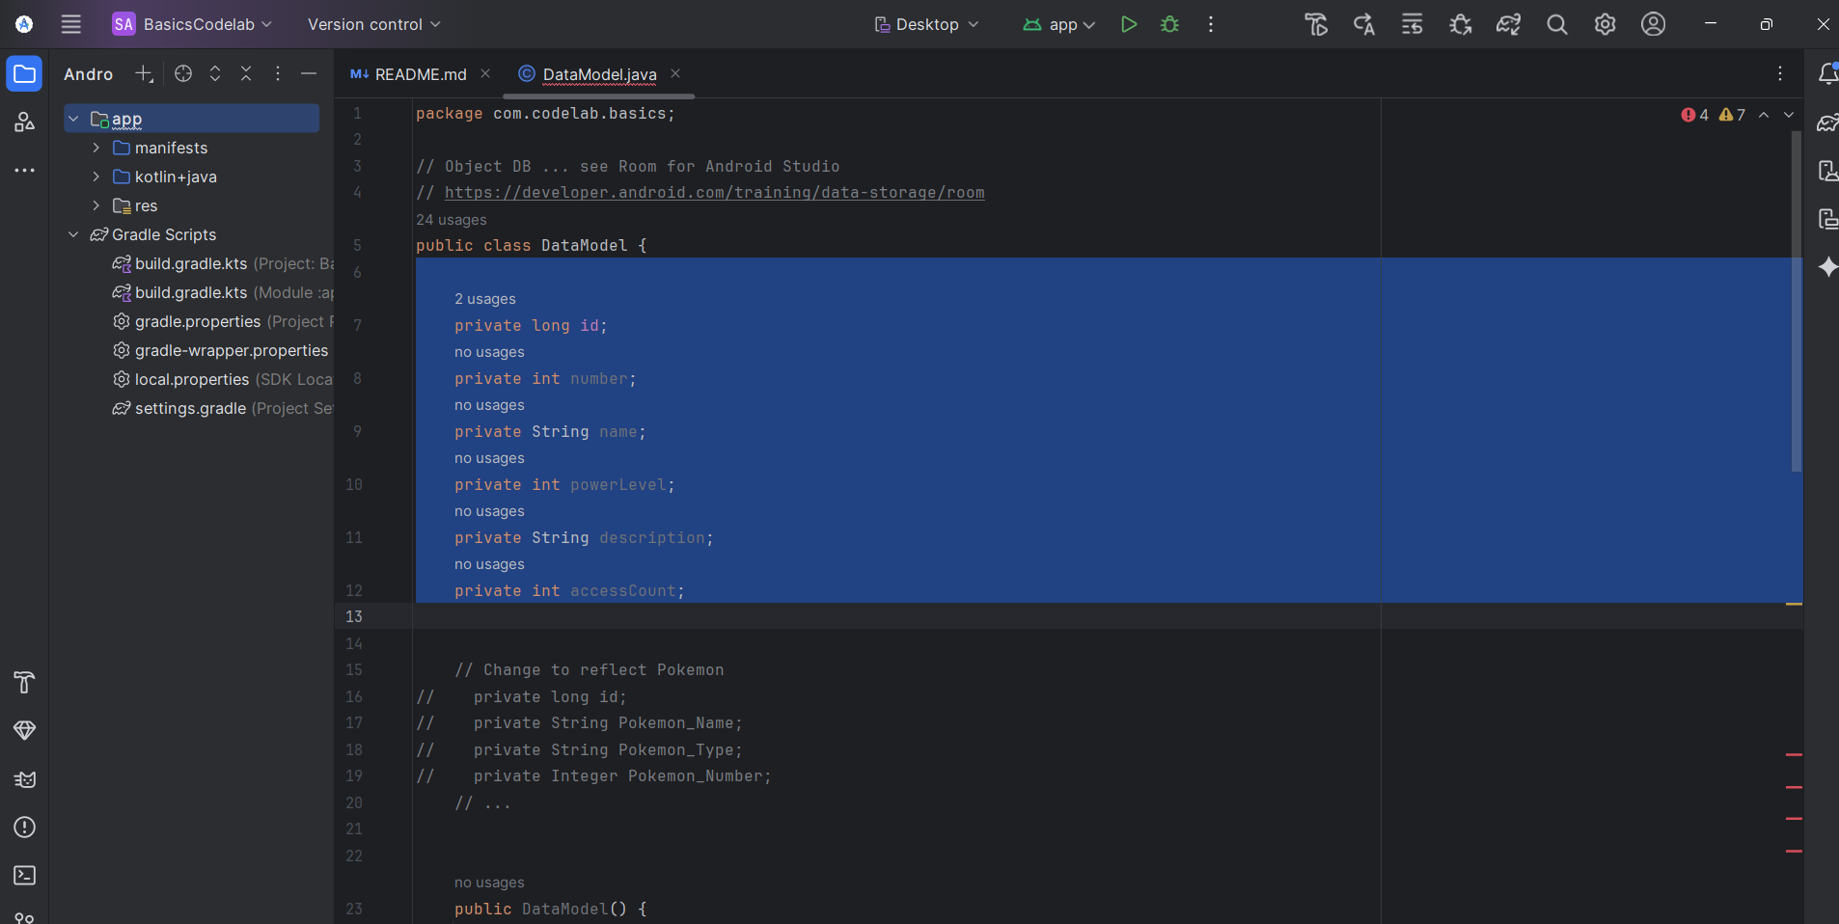

Update Constructors:

From:

public DataModel() {

this.setId(0);

this.setModelName("default modelName");

this.setModelNumber(0);

}

public DataModel(long id, String modelName, Integer modelNumber) {

this.setId(id);

this.setModelName(modelName);

this.setModelNumber(modelNumber);

}

To:

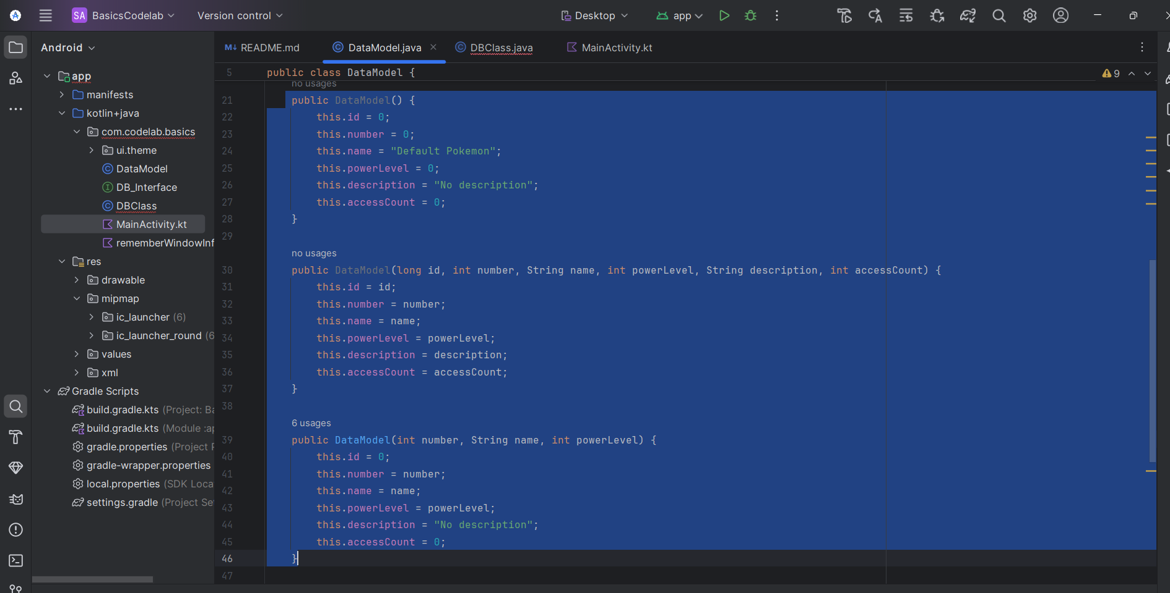

Updated toString() Method:

Old toString() (before changes)

@Override  
public String toString() {  
 return "DataModel{" +  
 "id=" + getId() +  
 ", modelName='" + getModelName() + '\'' +  
 ", modelNumber=" + getModelNumber();  
}

To:

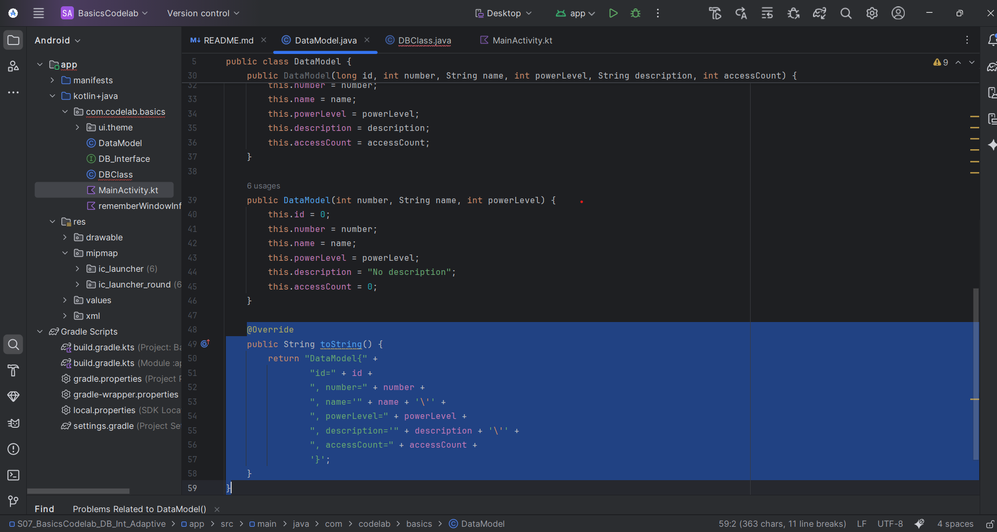

Add/Get/Set methods for the new fields:

public long getId() {

return id;

}

public void setId(long id) {

this.id = id;

}

public String getModelName() {

return str_col;

}

public void setModelName(String modelName) {

this.str_col = modelName;

}

public Integer getModelNumber() {

return num_col;

}

public void setModelNumber(Integer modelNumber) {

this.num_col = modelNumber;

}

To:

// --- Getters & Setters ---

public long getId() { return id; }

public void setId(long id) { this.id = id; }

public int getNumber() { return number; }

public void setNumber(int number) { this.number = number; }

public String getName() { return name; }

public void setName(String name) { this.name = name; }

public int getPowerLevel() { return powerLevel; }

public void setPowerLevel(int powerLevel) { this.powerLevel = powerLevel; }

public String getDescription() { return description; }

public void setDescription(String description) { this.description = description; }

public int getAccessCount() { return accessCount; }

public void setAccessCount(int accessCount) { this.accessCount = accessCount; }

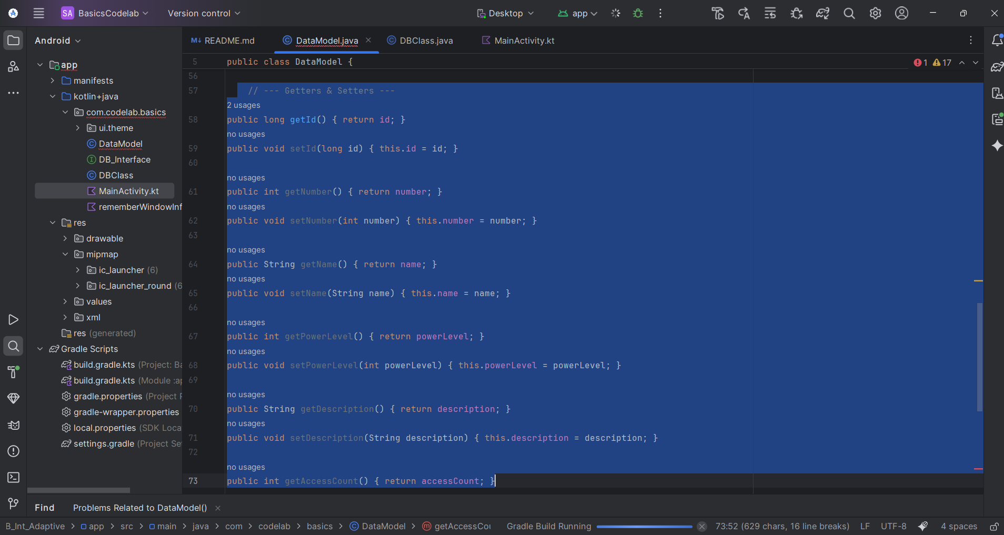

Update the sample rows:

The old code was:

DataModel a = new DataModel(1, "Ford", 101);

this.save(a);

db.execSQL("INSERT INTO sample_table(str_col,num_col) VALUES('Toyota', 200)");

db.execSQL("INSERT INTO sample_table(str_col,num_col) VALUES('Honda', 300)");

db.execSQL("INSERT INTO sample_table(str_col,num_col) VALUES('GM', 400)");

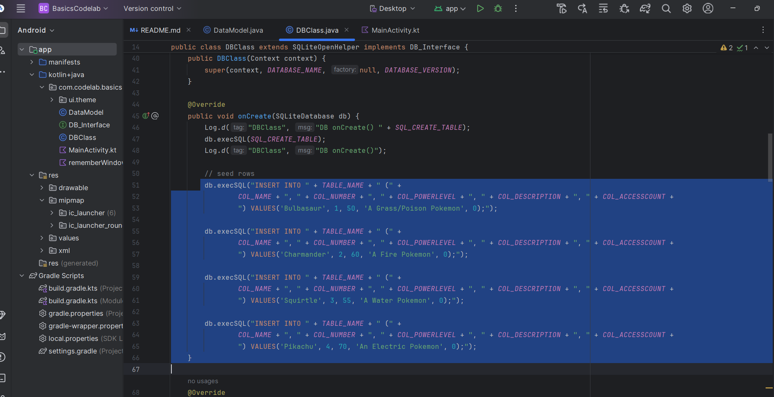

Update findAll() Method

Old Code:

item = new DataModel(

cursor.getInt(0), // id

cursor.getString(1),// str_col

cursor.getInt(2) // num_col

);

To:

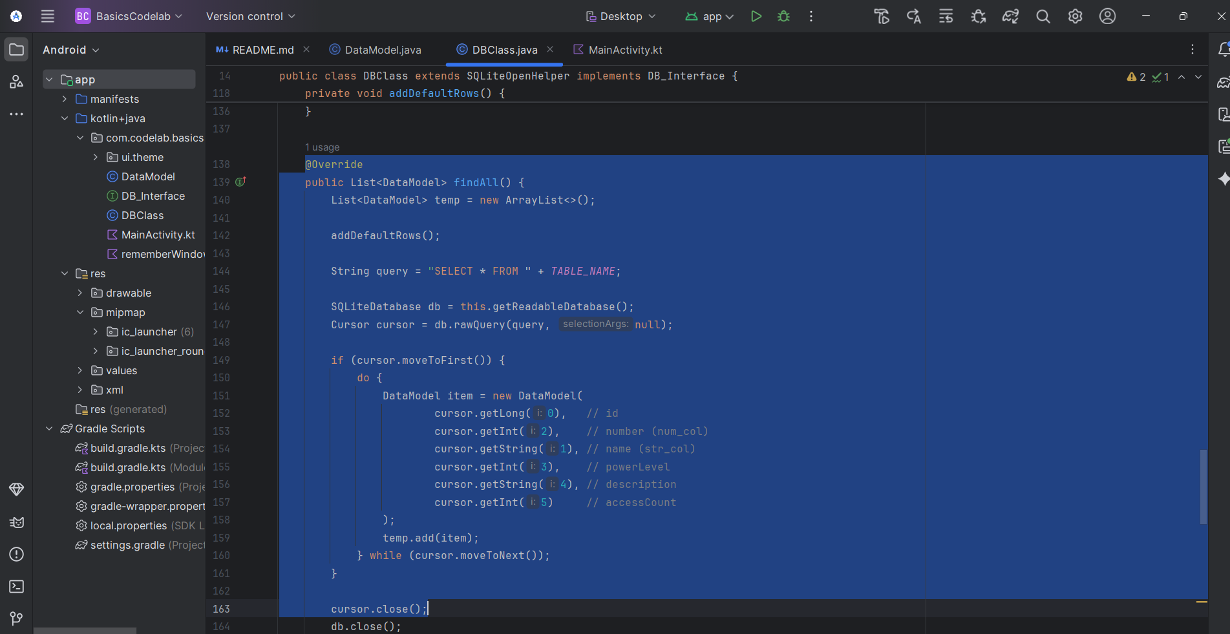

Update addDefaultRows()

Old Code:

DataModel a = new DataModel(1, "Ford", 101);

this.save(a);

a = new DataModel(2, "GM", 201);

this.save(a);

a = new DataModel(3, "Tesla", 301);

this.save(a);

a = new DataModel(4, "Toyota", 401);

this.save(a);

DataModel a = new DataModel(1, "Rusty Bucket", r.nextInt(500));

this.save(a);

To:

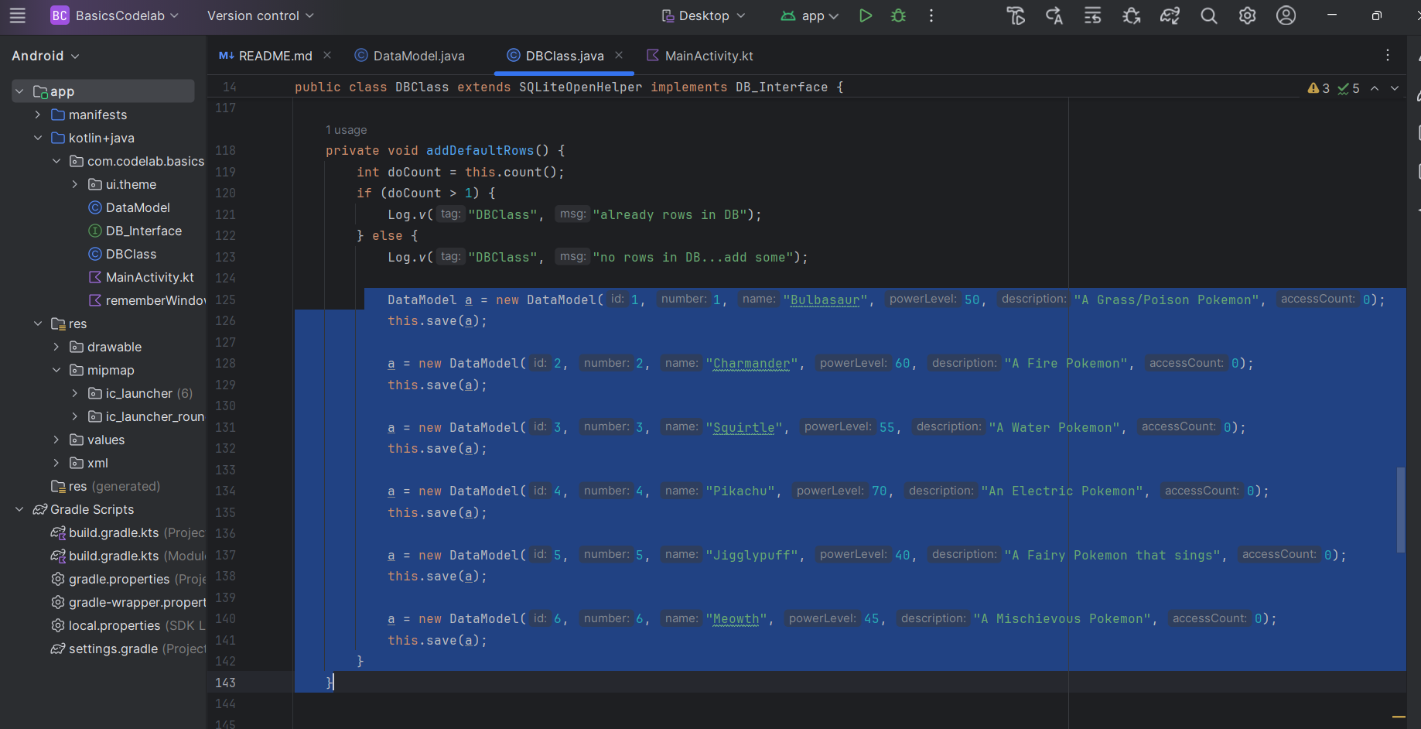

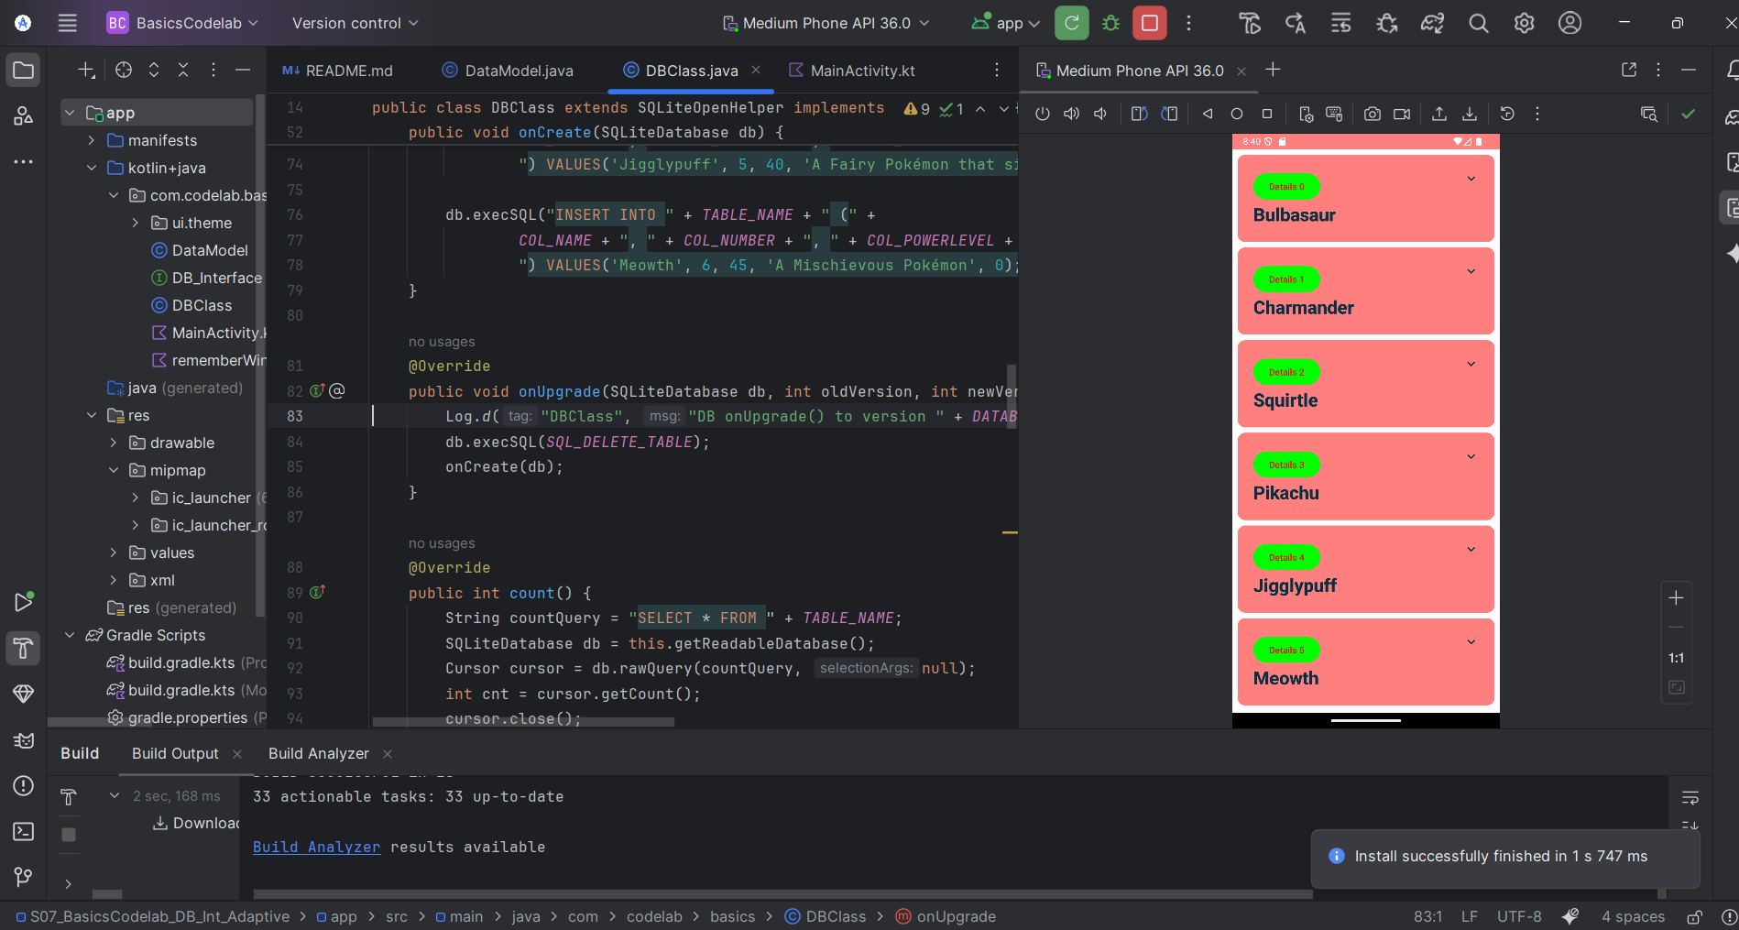

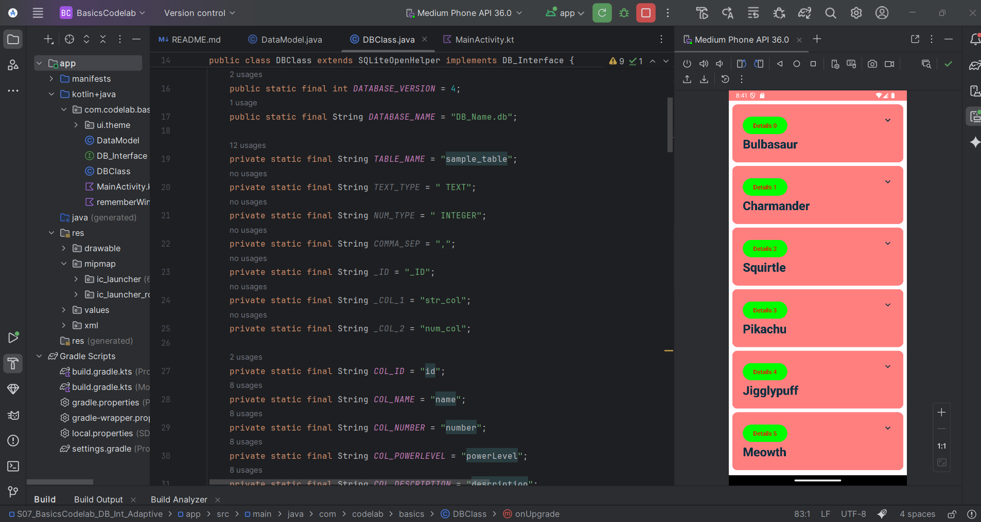

**Section 2 – Compose Main Screen with Favorite Pokémon**

Update Main Screen to Show Favorite Pokémon

Old code:

@Override  
public DataModel getMax() {  
 return null;  
  
 // get all  
  
 // find max  
  
 // return max datamodel  
  
}

To:

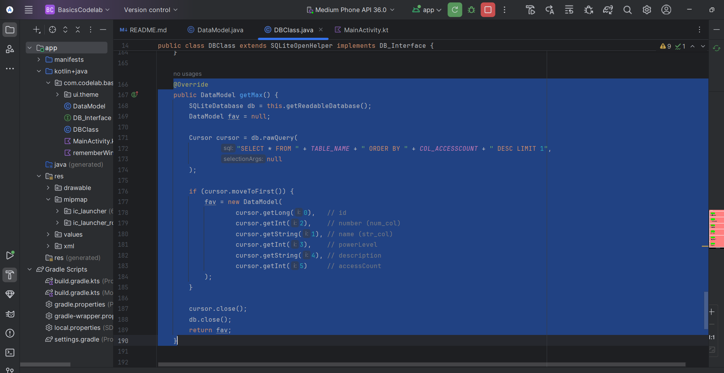

Update ShowPageMaster

Old Code:

@Composable

private fun ShowPageMaster(

modifier: Modifier = Modifier,

names: List<DataModel>,

updateIndex: (index: Int) -> Unit,

DBtest: DBClass

) {

// you have all "names"

// find most accessed name

// Show that ... most accessed name

LazyColumn(

modifier = modifier.padding(vertical = 4.dp)

) {

itemsIndexed(items = names) { pos, name ->

Log.d("CodeLab_DB", "Item at index $pos is $name")

ShowEachListItem(name = name, pos, updateIndex, DBtest)

}

}

}

To:

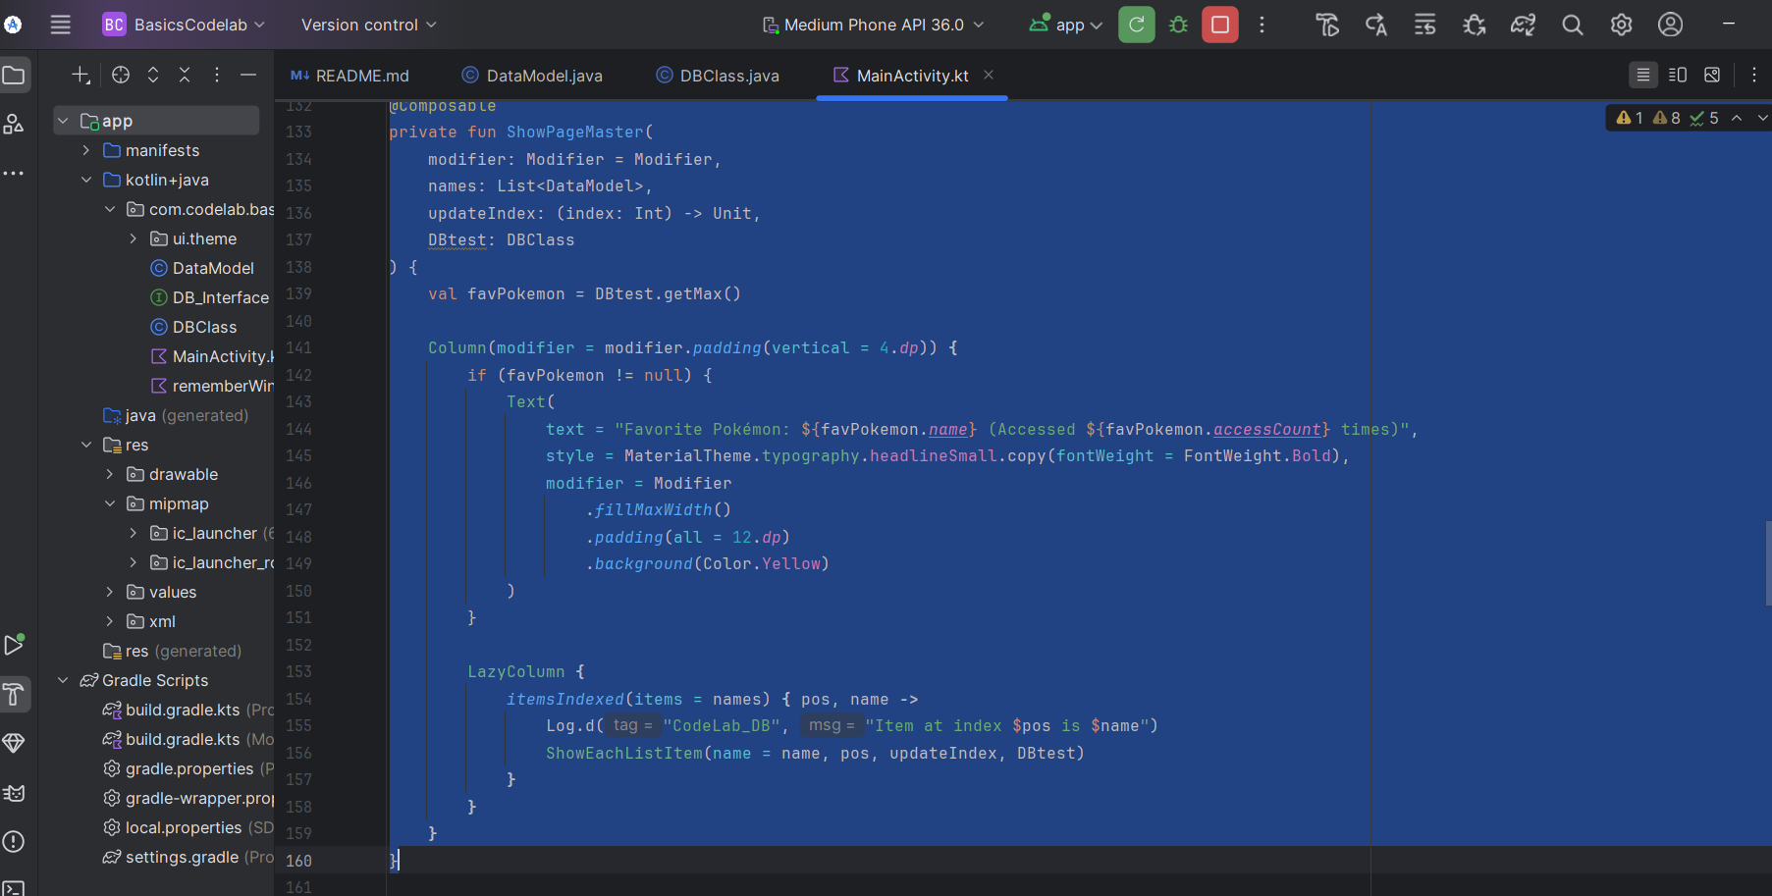

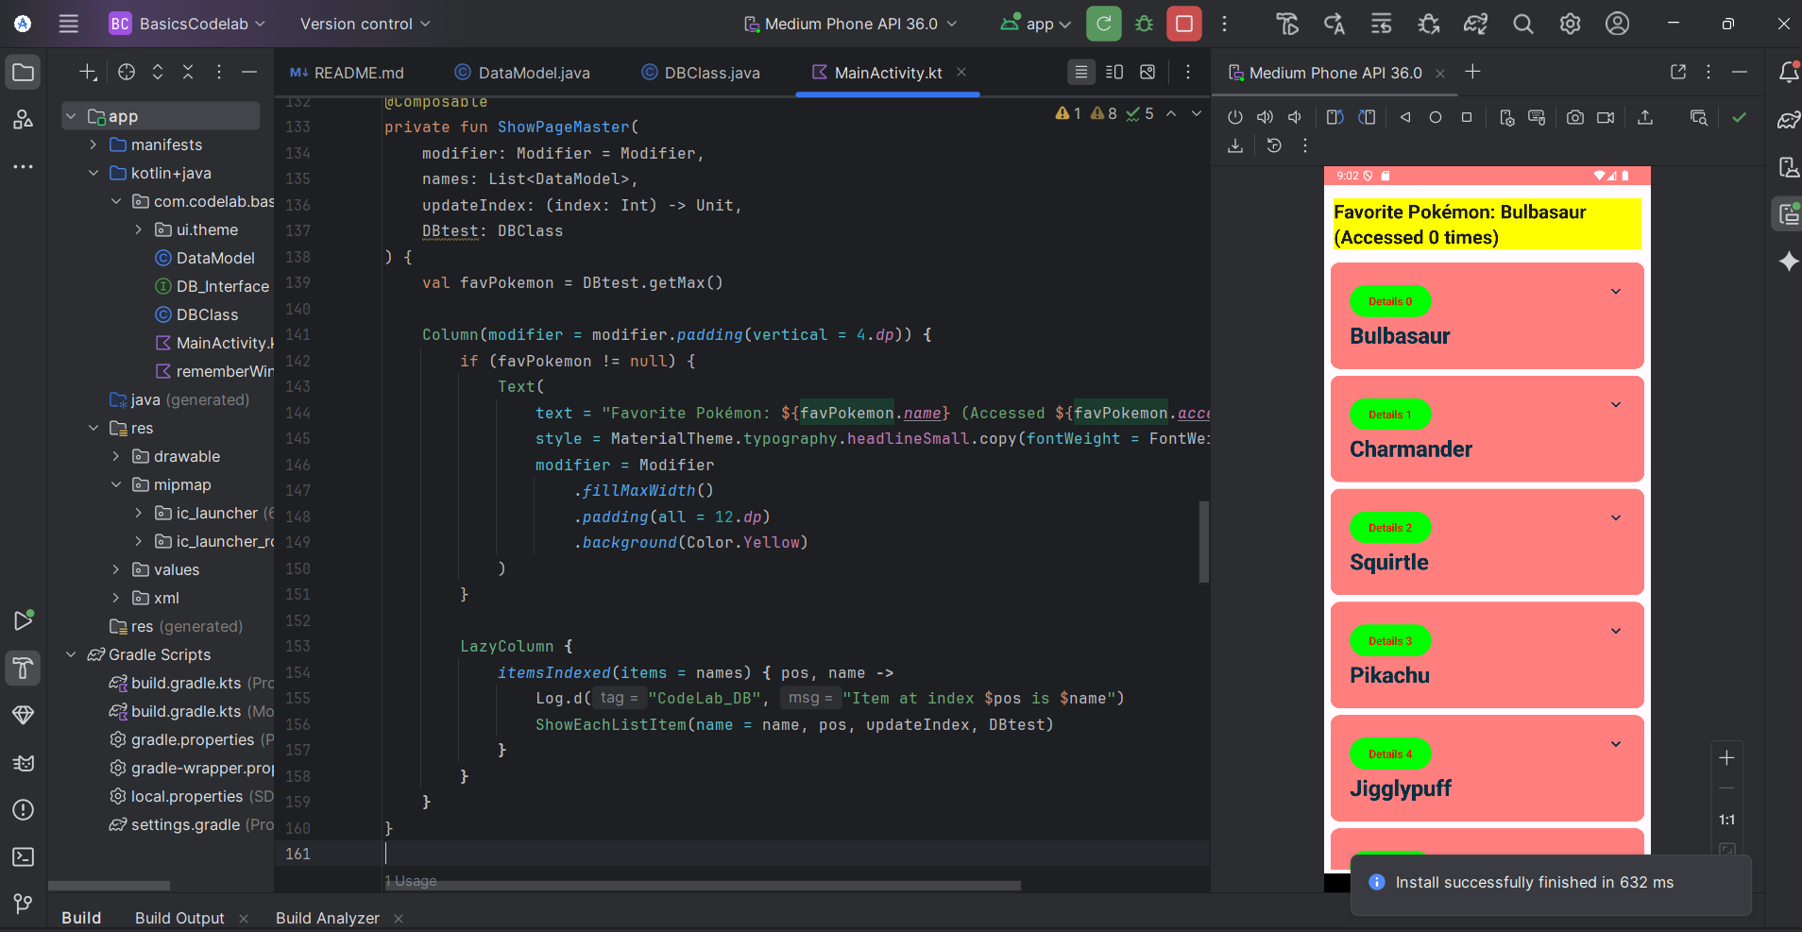

**I tapped (Bulbasaur) one time and rerun again, I got this:**

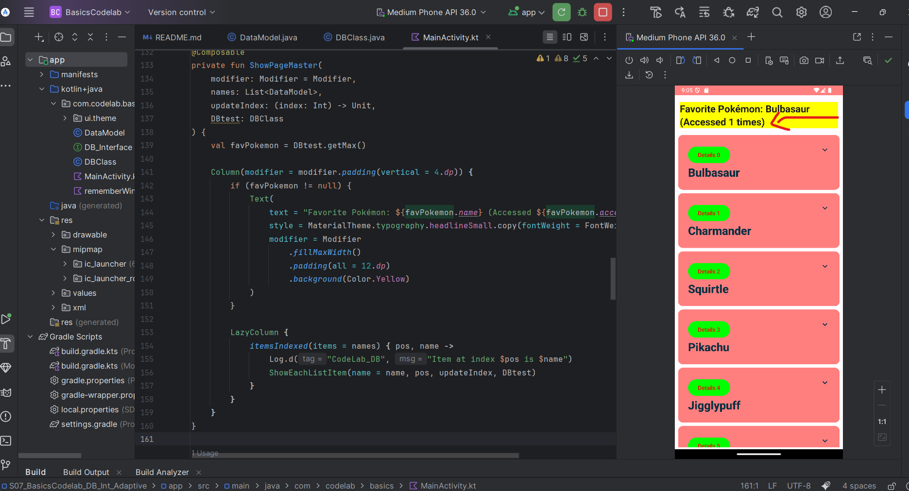

**Section 3 – Create at least 6 Pokémon Items in the DB**

Old Code:

DataModel a = new DataModel(1, "Ford", 101);

this.save(a);

a = new DataModel(2, "GM", 201);

this.save(a);

a = new DataModel(3, "Tesla", 301);

this.save(a);

a = new DataModel(4, "Toyota", 401);

this.save(a);

To:

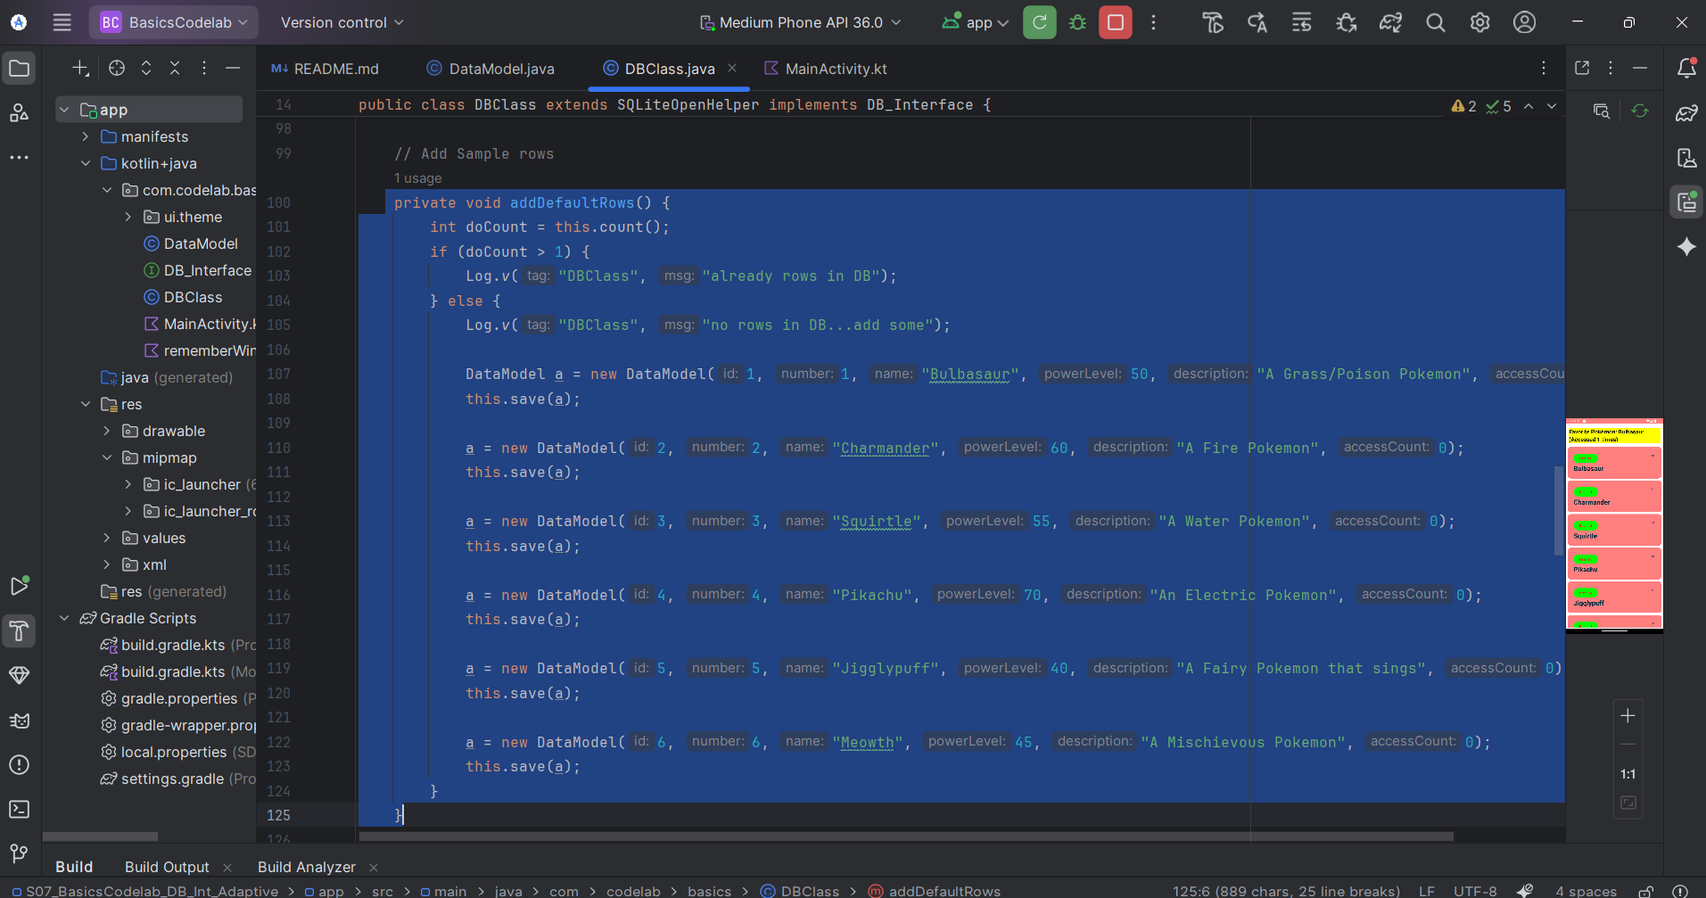

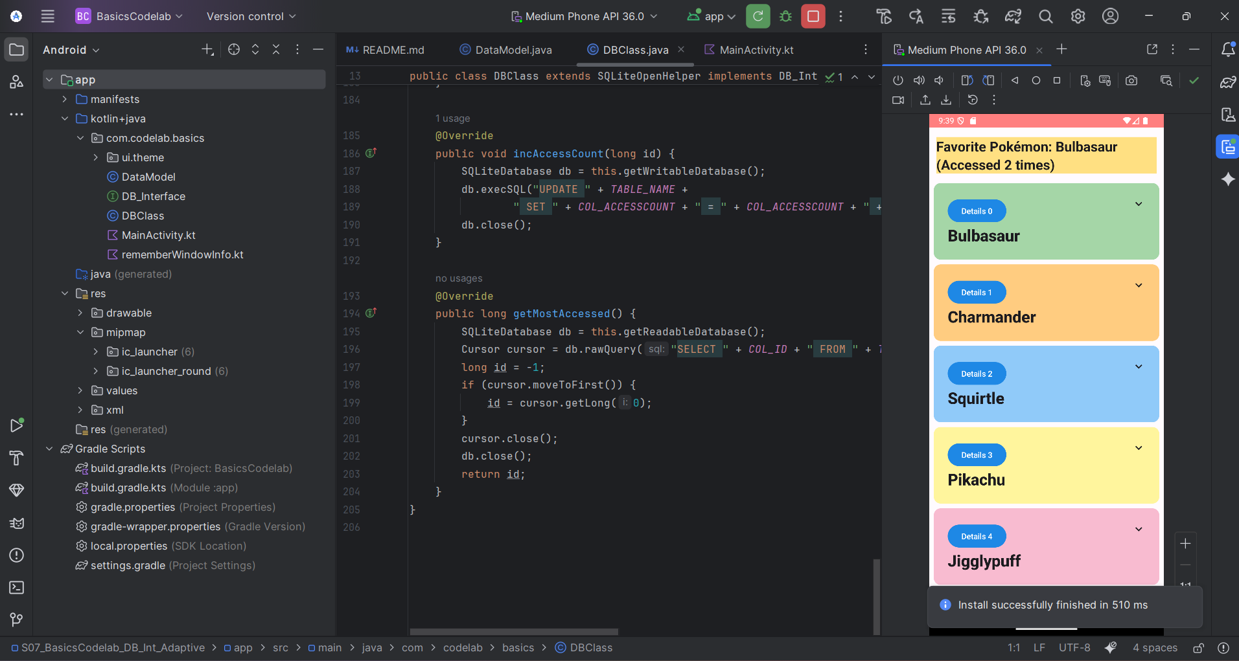

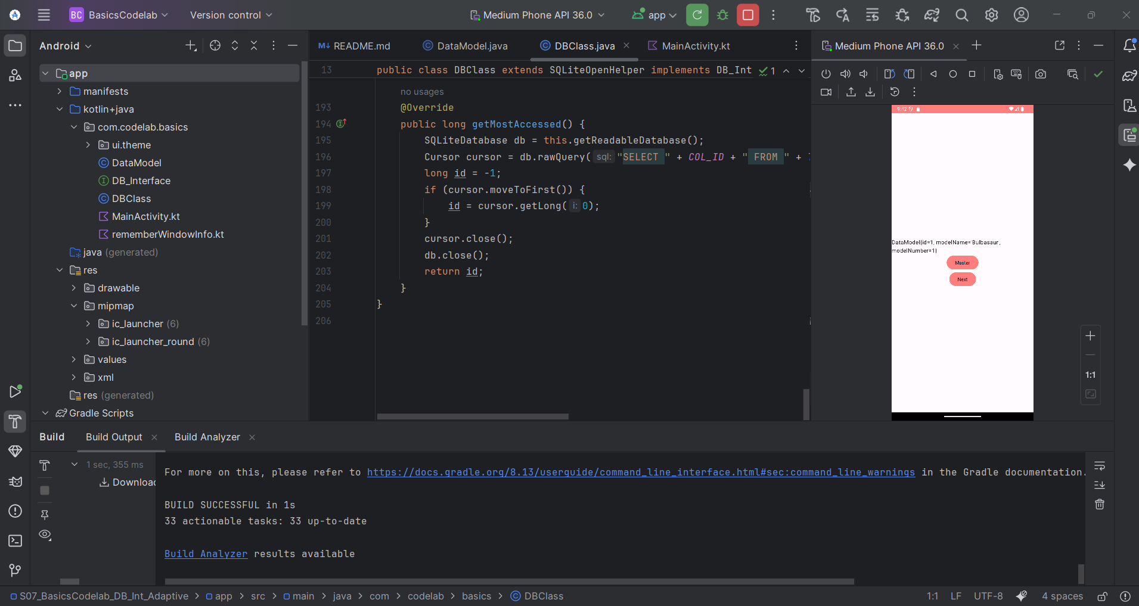

**Section 4 - access of a record increments an "access count" field of that Pokémon**

Update incAccessCount() Method.

Old Code:

@Override

public void incAccessCount(long id) {

Log.v("DBClass", "id = " + id);

// update sample_table set num_col = num_col + 1 where id=1;

String cmdString = "update " + TABLE_NAME + " set num_col = num_col + 1 where id=" + id;

Log.v("DBClass", "cmdString = " + cmdString);

SQLiteDatabase db = this.getWritableDatabase();

db.execSQL(cmdString);

db.close();

}

To:

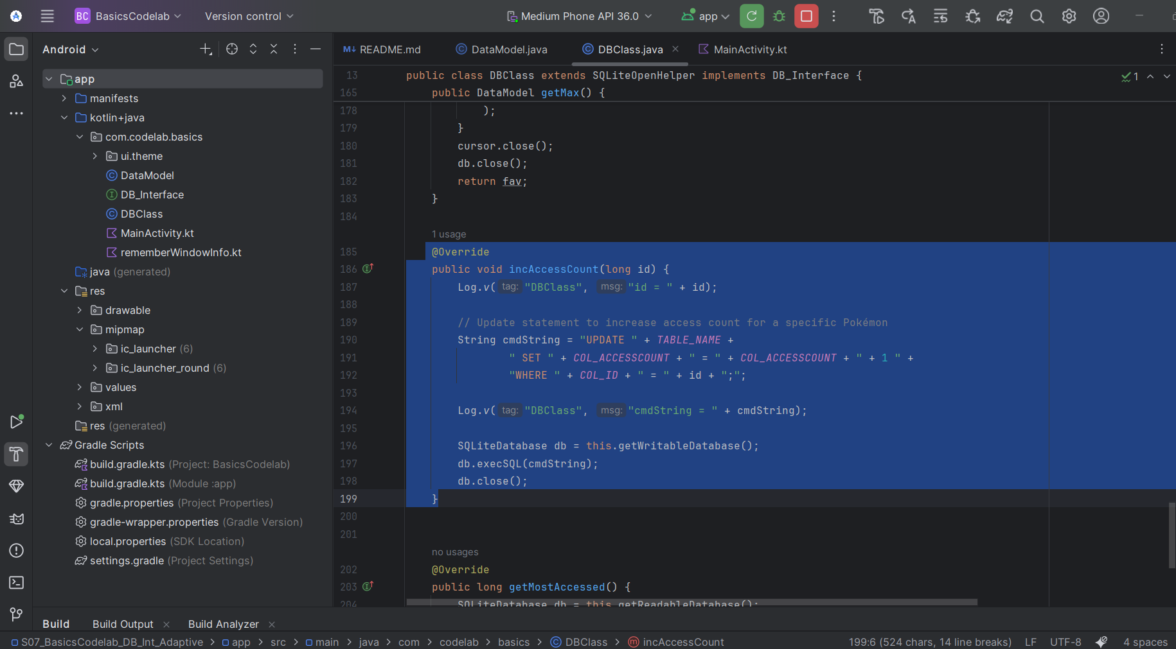

Access Count Increment in Action:

Old Code:

@Override

public DataModel getMax() {

return null;

// get all

// find max

// return max datamodel

}

To:

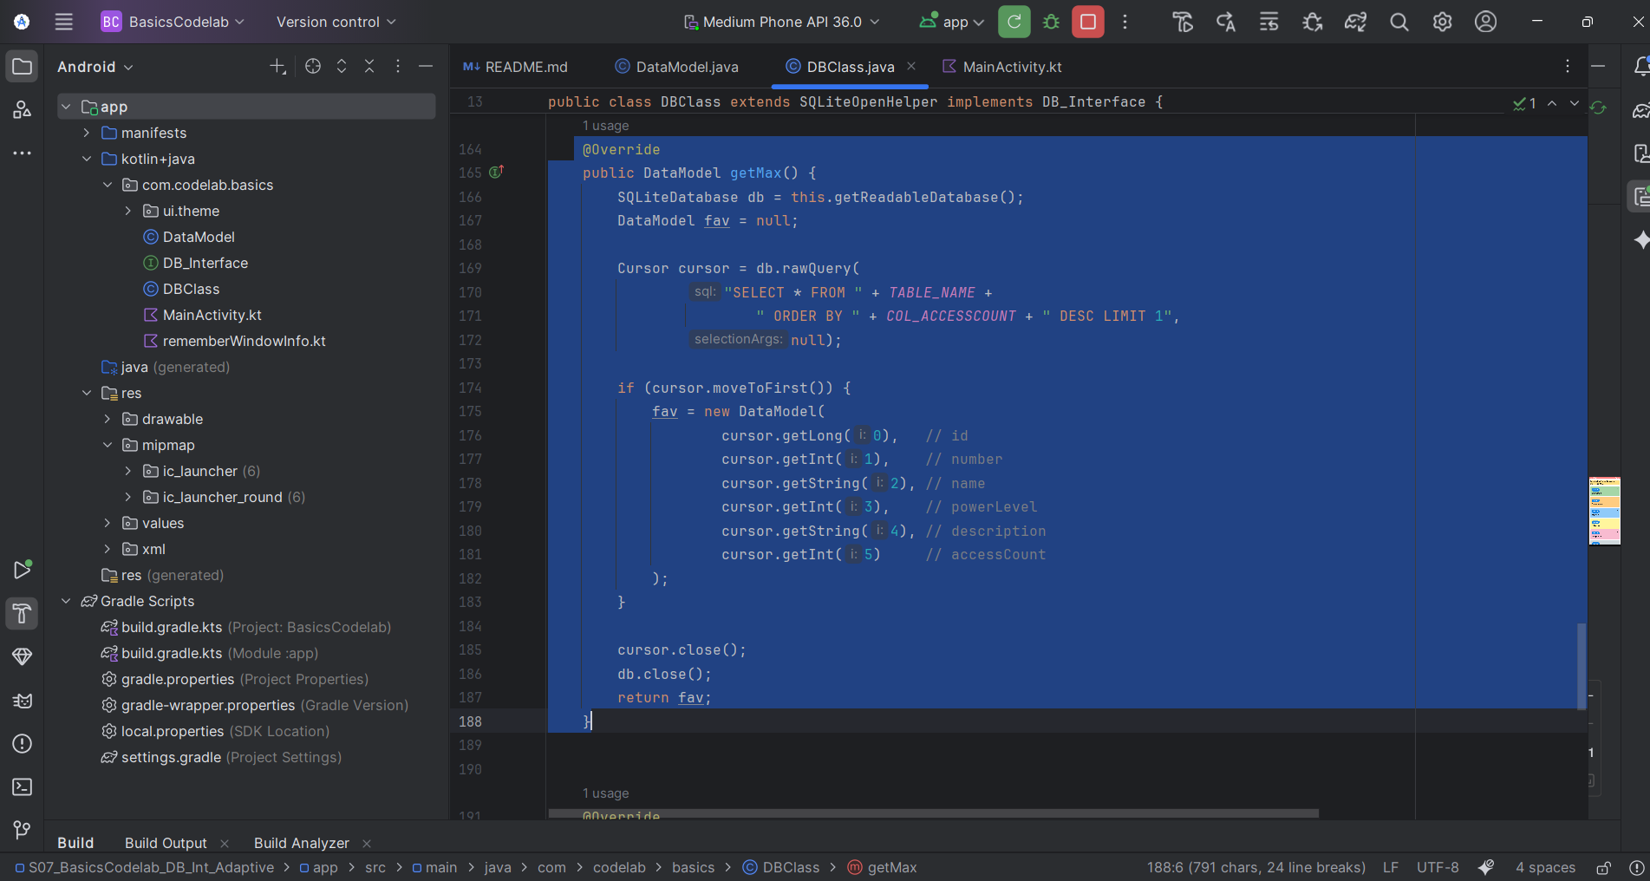

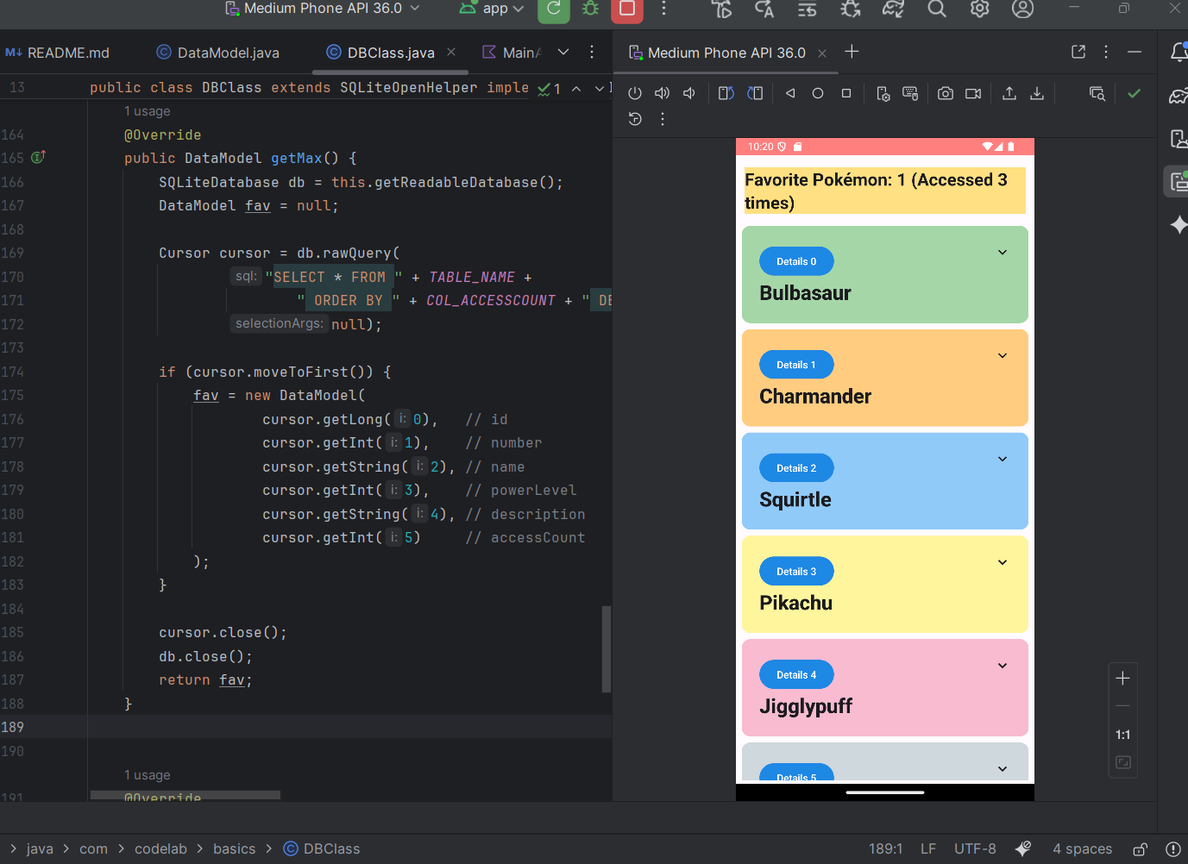

**Section 5 – Add New DB Fields to Schema**

New Column Definitions: Old Code: private static final String _COL_1 = "str_col"; private static final String _COL_2 = "num_col";

To:

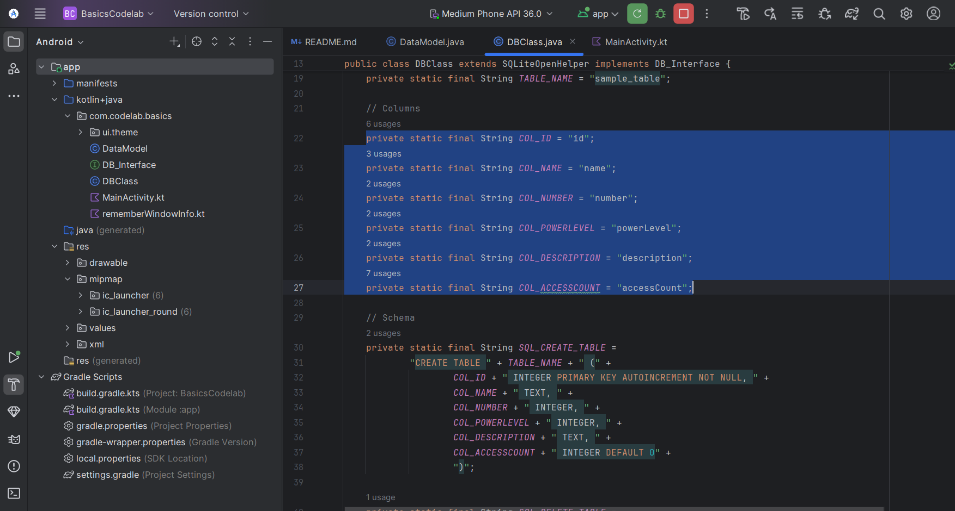

Update save() Method Old Code: ContentValues values = new ContentValues(); values.put(COL_1, dataModel.getName()); values.put(COL_2, dataModel.getNumber());

To:

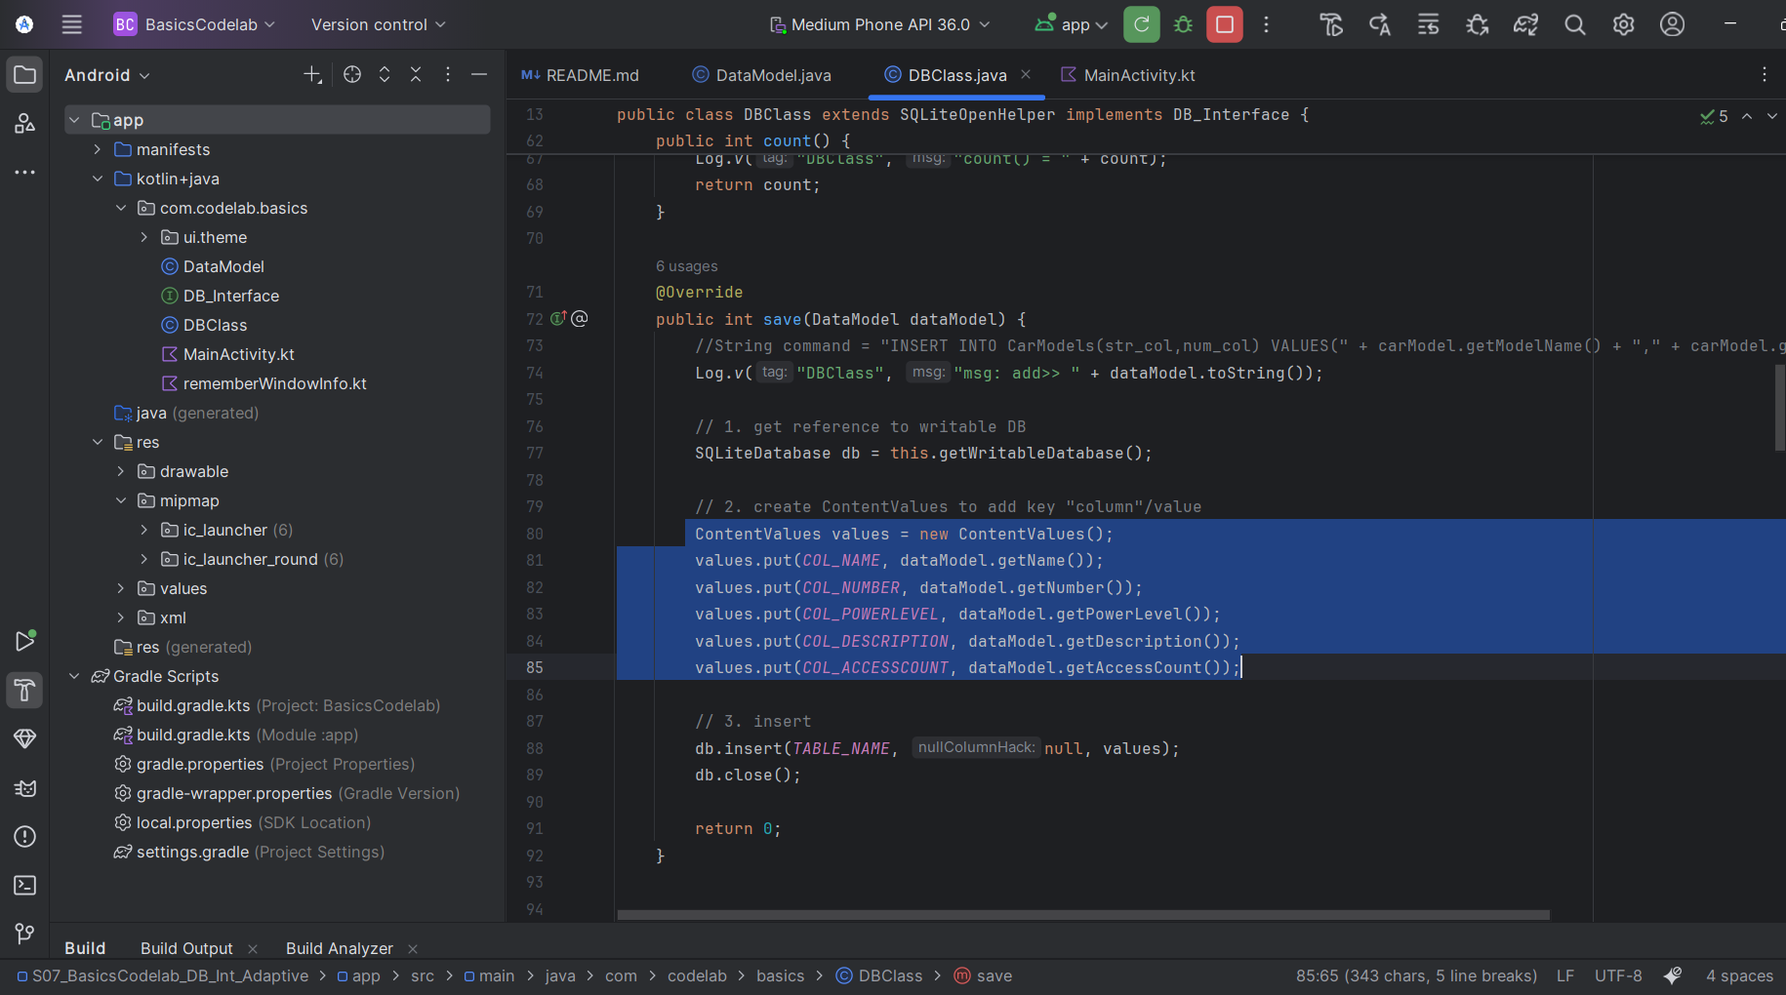

**Section 6 – Update DB Code**

Update DB insert code (DBClass.java) :

Old code:

values.put(COL_1, dataModel.getModelName());

values.put(COL_2, dataModel.getModelNumber());

To:

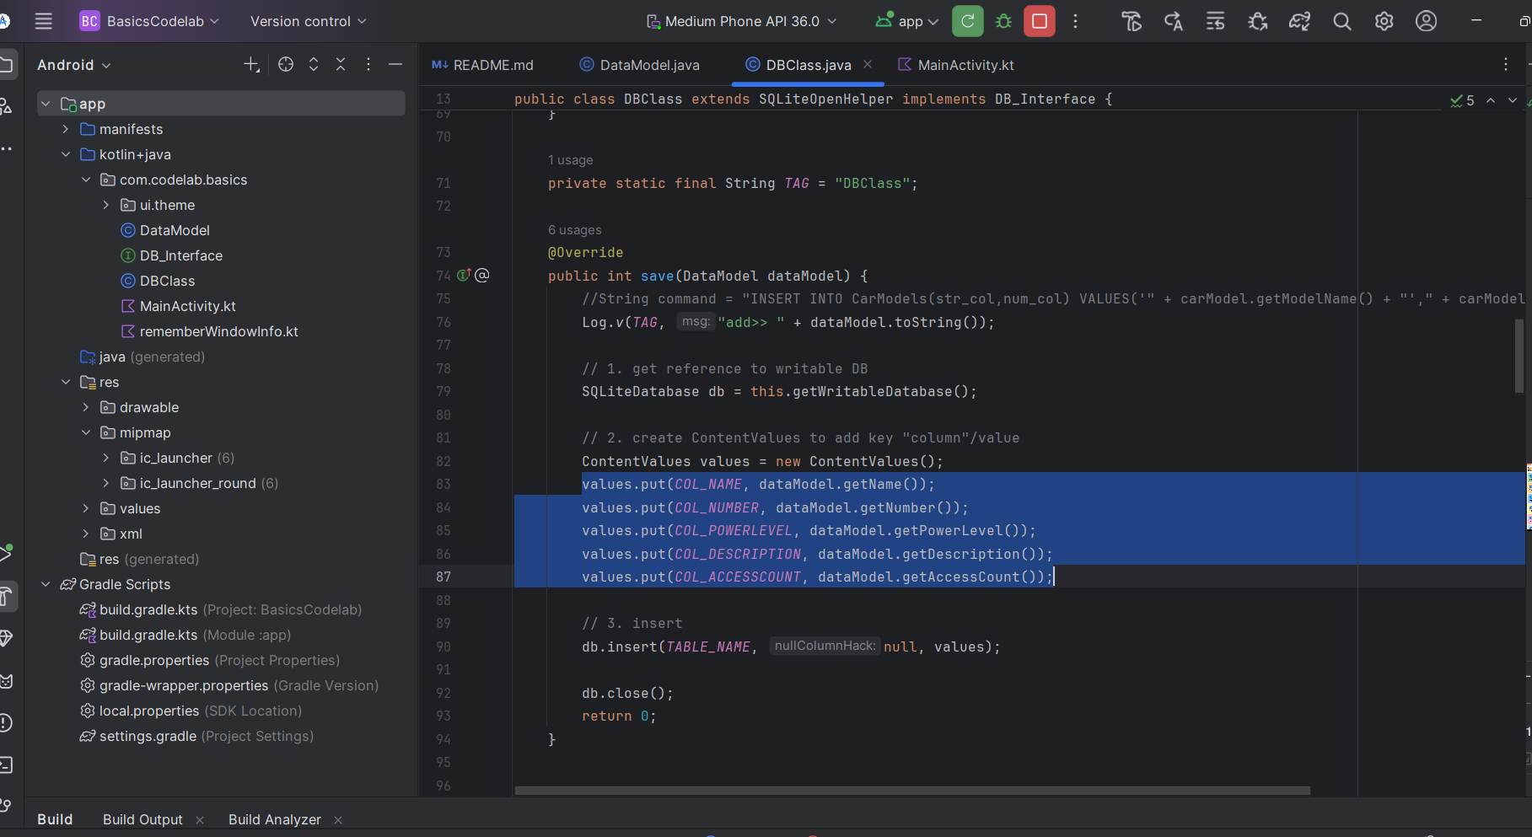

Update the table creation SQL Old Code: private static final String SQL_CREATE_TABLE = "CREATE TABLE " + TABLE_NAME + " (id INTEGER PRIMARY KEY AUTOINCREMENT NOT NULL, str_col VARCHAR(256), num_col INTEGER)";

To:

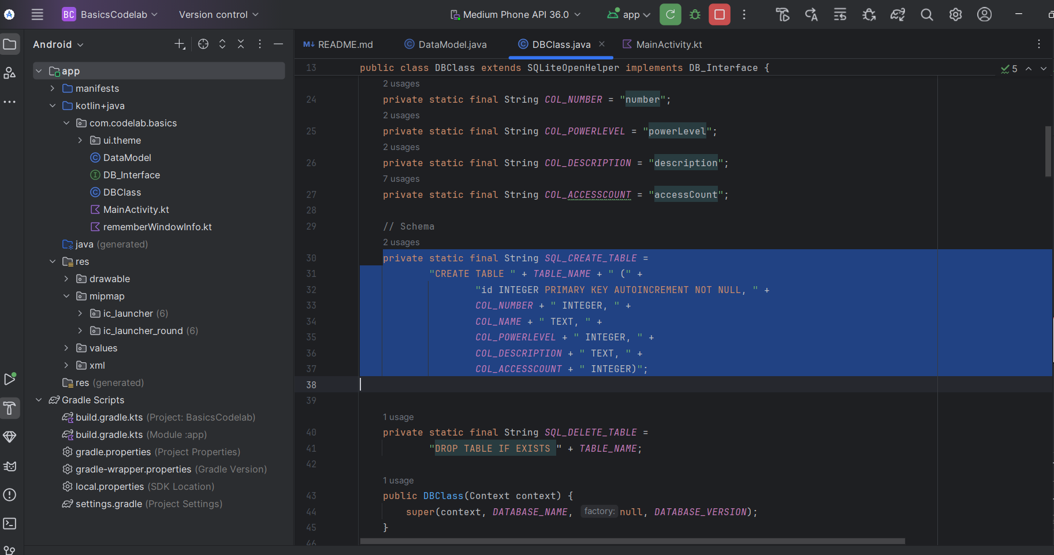

**Section 7 – UI Side (Compose Changes)**

Update UI References in MainActivity:

Old Code:

text = name.modelName

New Code:

text = name.name

To:

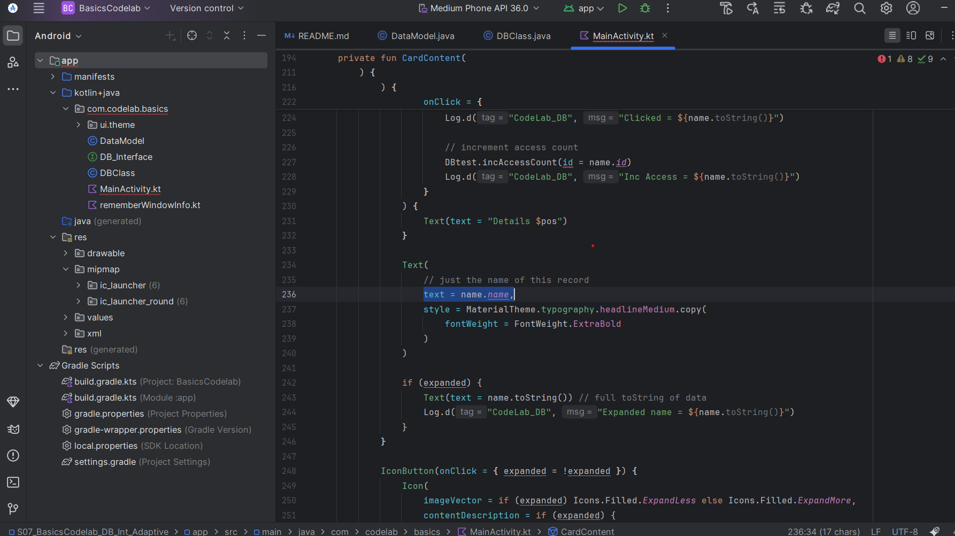

Change Background Color of List Items

Old Code:

Card(

colors = CardDefaults.cardColors(

containerColor = MaterialTheme.colorScheme.primary

),

modifier = Modifier.padding(vertical = 4.dp, horizontal = 8.dp)

) {

CardContent(name, pos, updateIndex, DBtest )

Log.d("CodeLab_DB", "Greeting: ")

}

To:

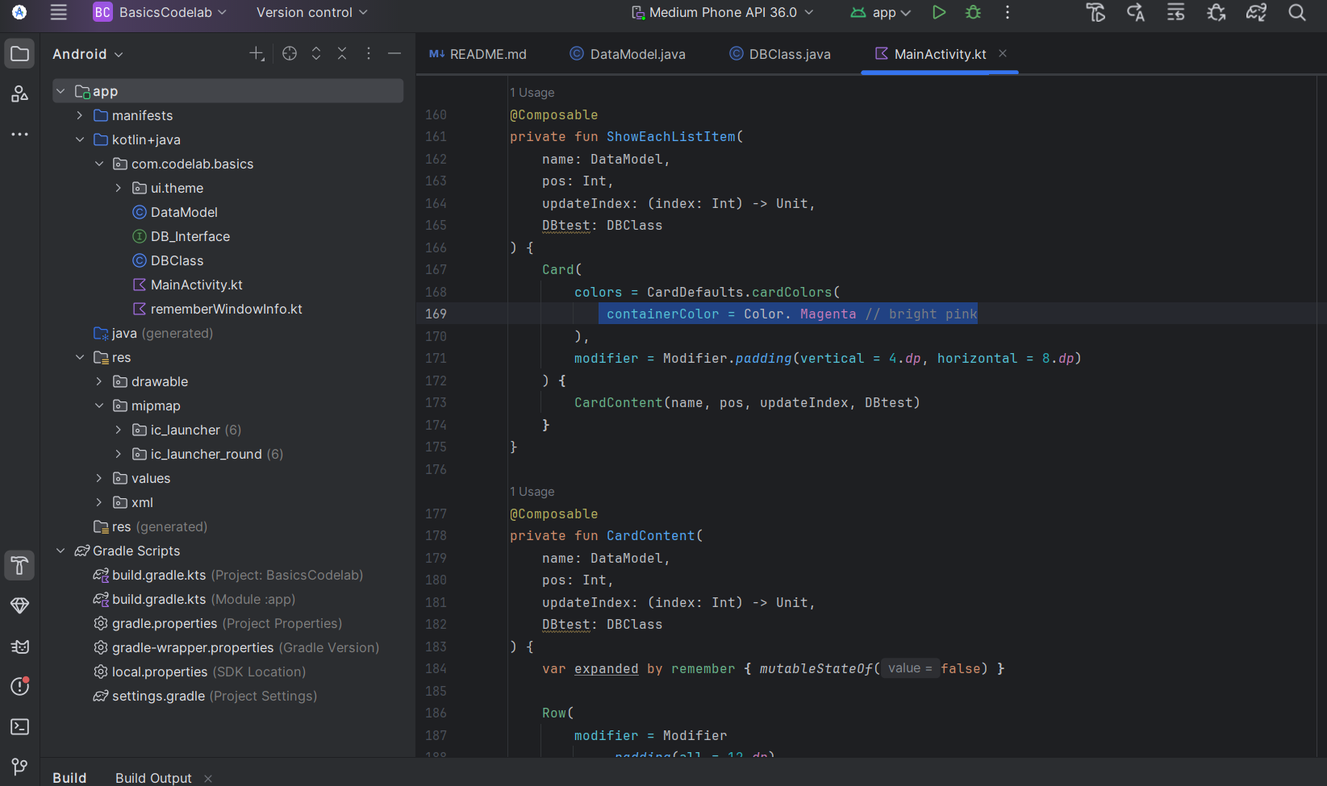

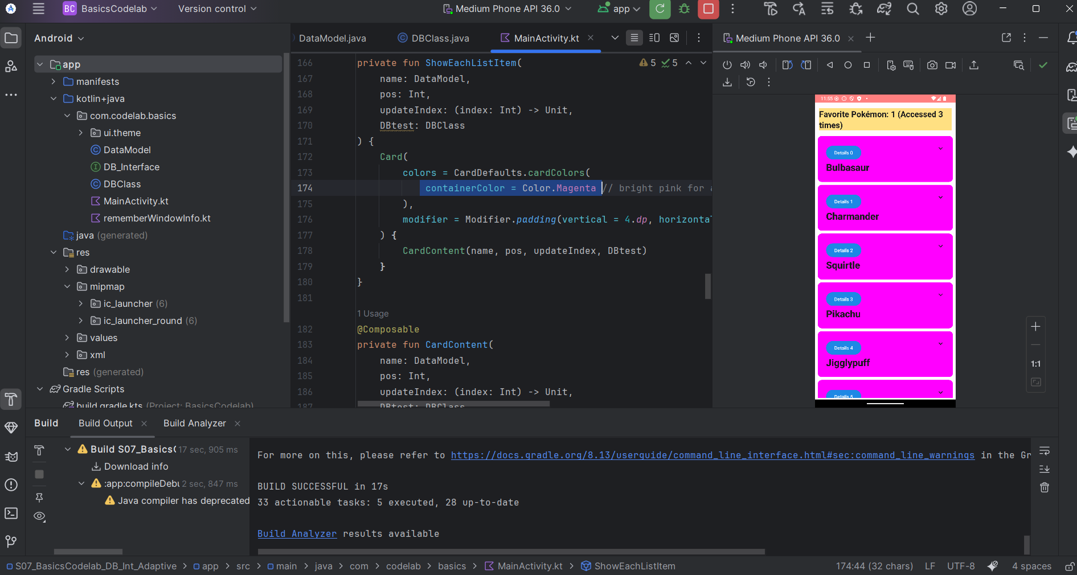

Change Button Colors

Old Code:

Button(

colors = ButtonDefaults.buttonColors(

containerColor = Color.Green,

contentColor = Color.Red

),

onClick = {

updateIndex(pos);

DBtest.incAccessCount(name.id)

})

{ Text(text = "Details ${pos}") }

To:

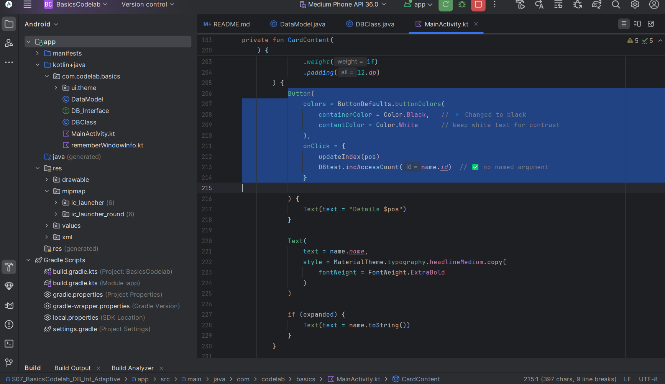

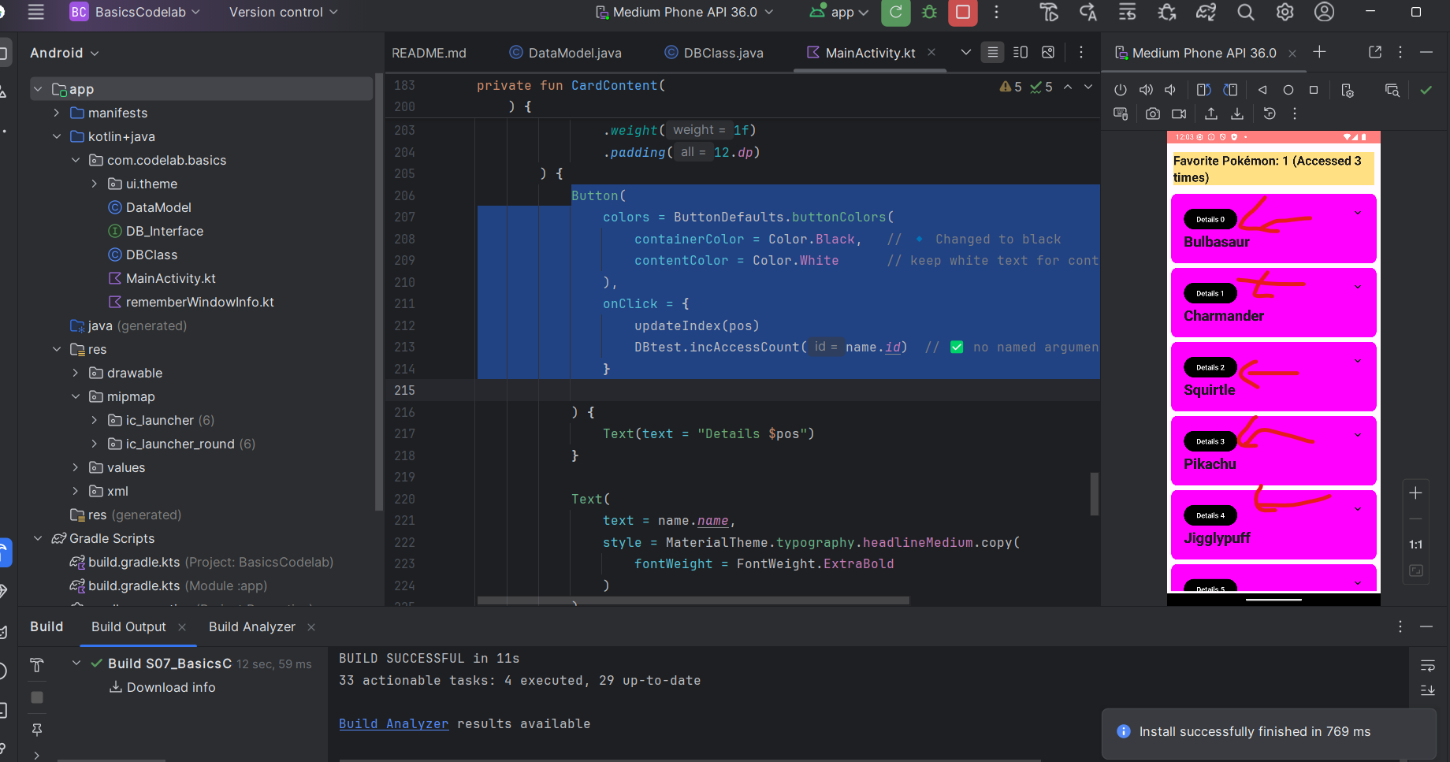

Make Pokémon names BIGGER and BOLDER

Old Code:

Text(

text = name.name,

style = MaterialTheme.typography.headlineMedium.copy(

fontWeight = FontWeight.ExtraBold

)

)

To:

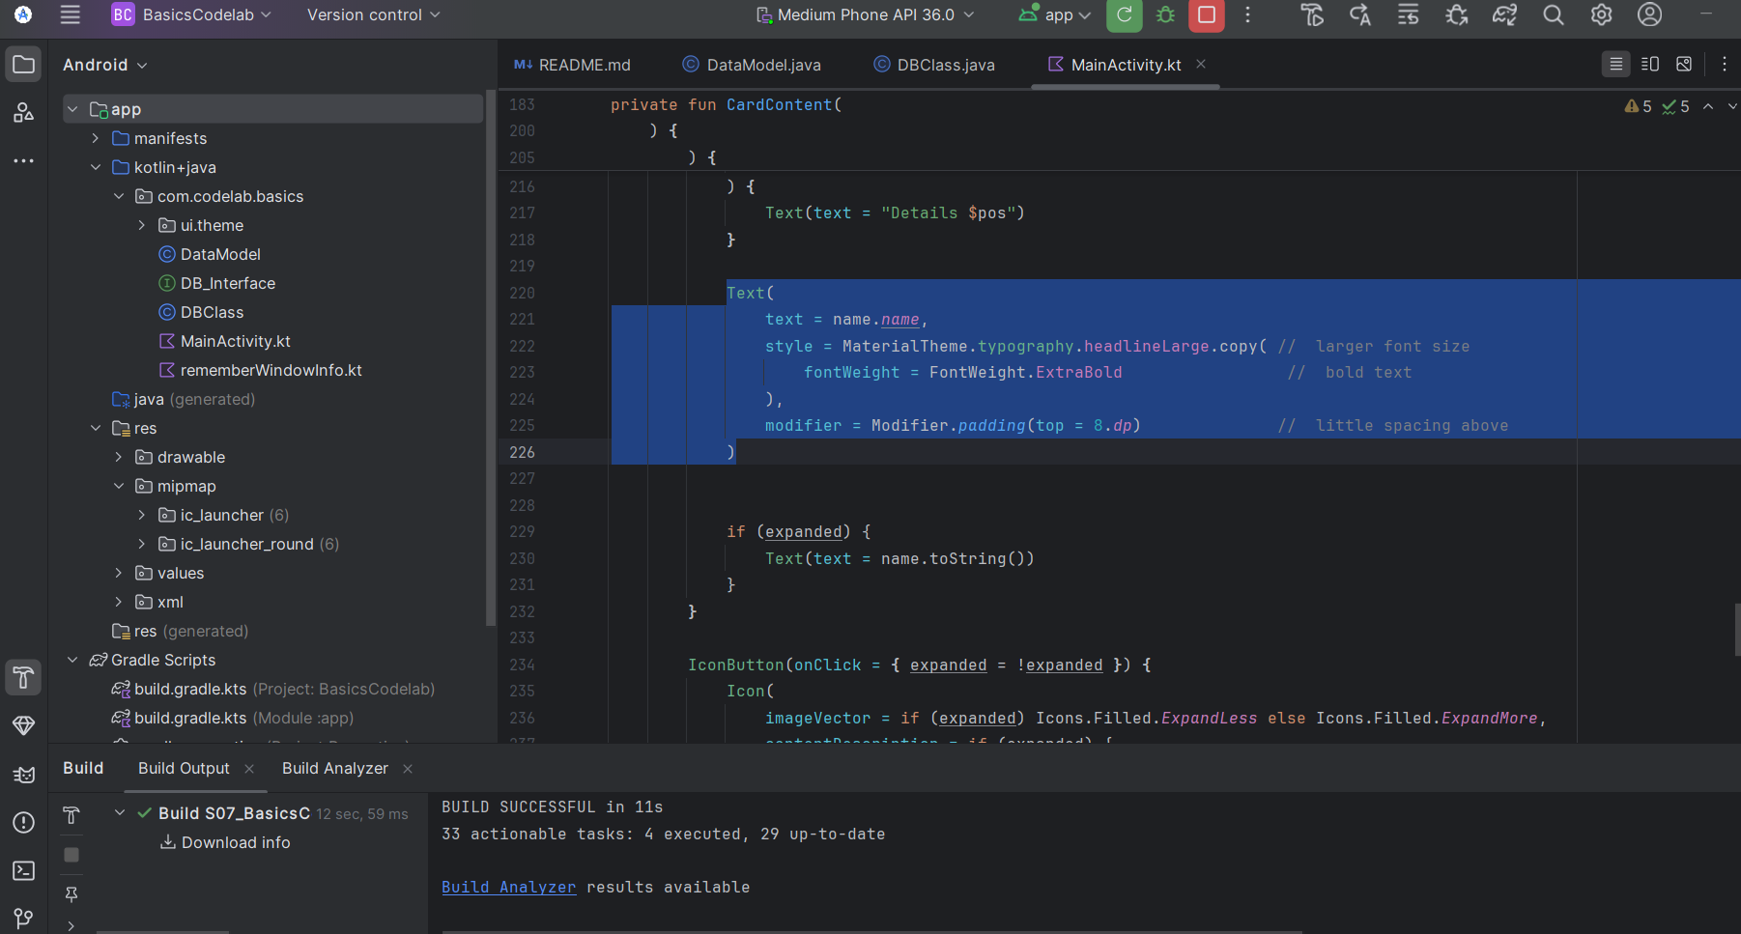

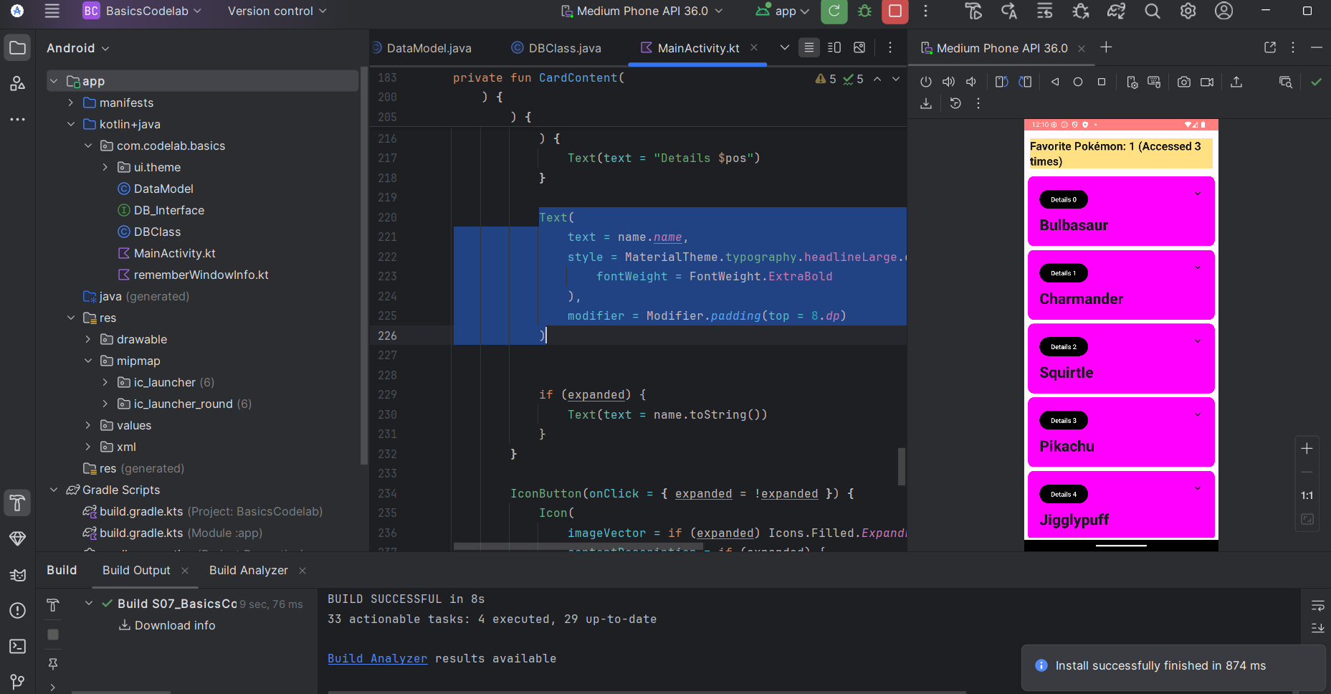

Add a border to the cards:

Old Code:

Card(

colors = CardDefaults.cardColors(

containerColor = Color.Magenta

),

modifier = Modifier.padding(vertical = 4.dp, horizontal = 8.dp)

) {

To:

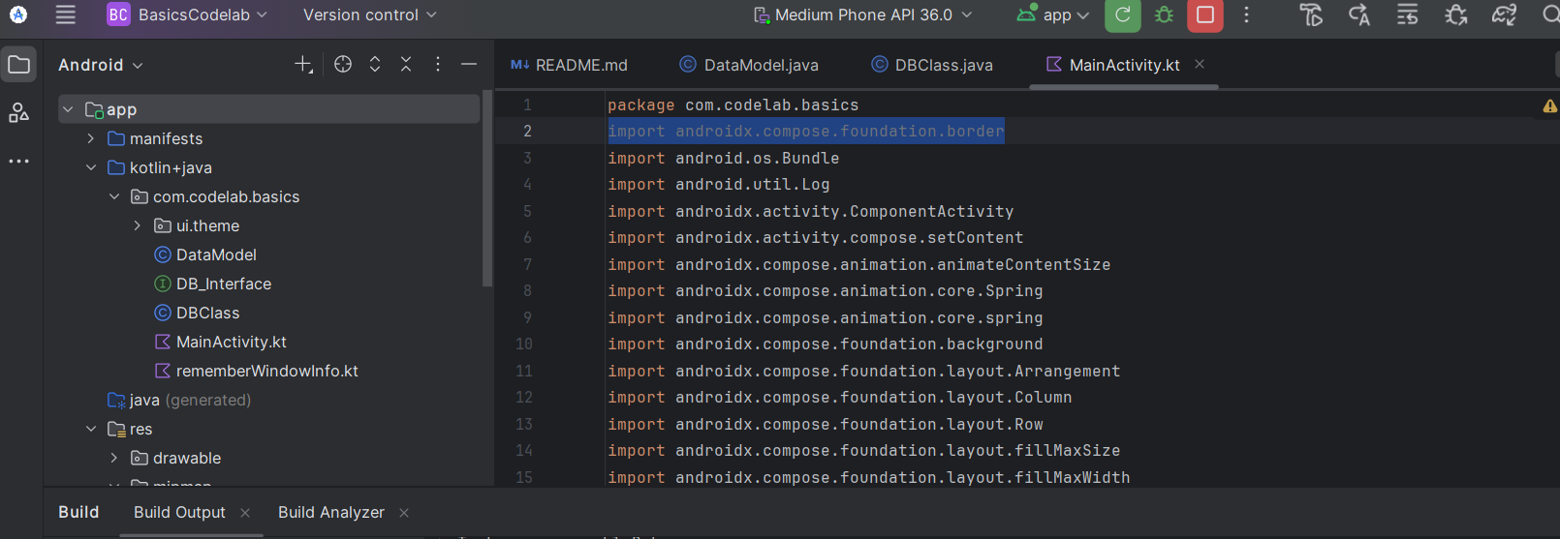

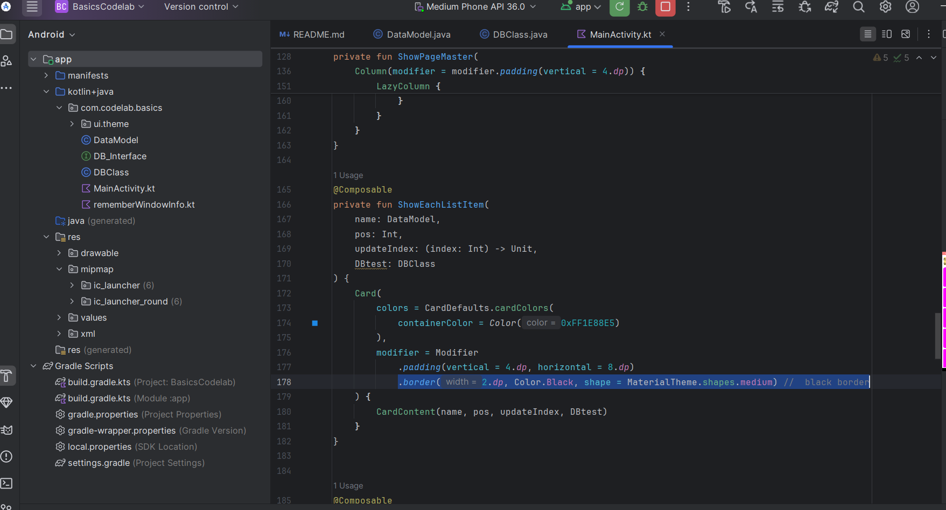

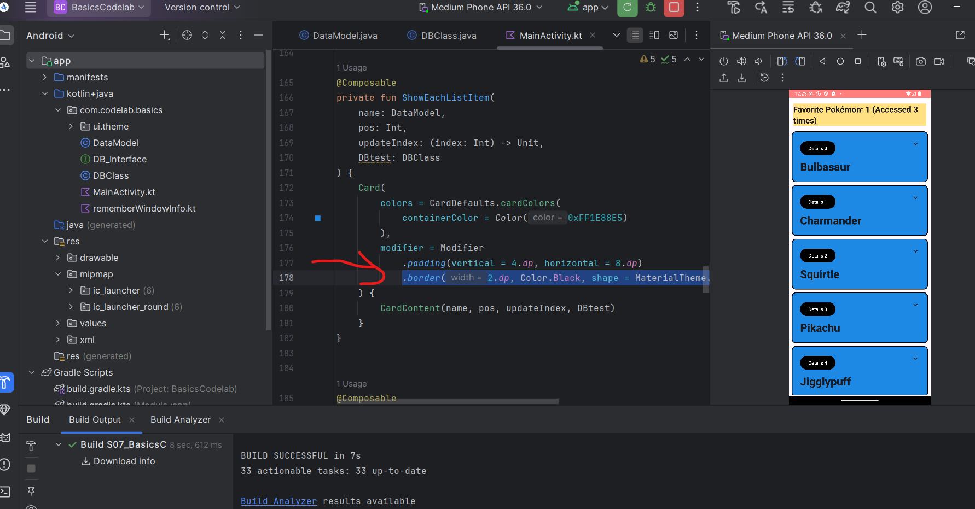

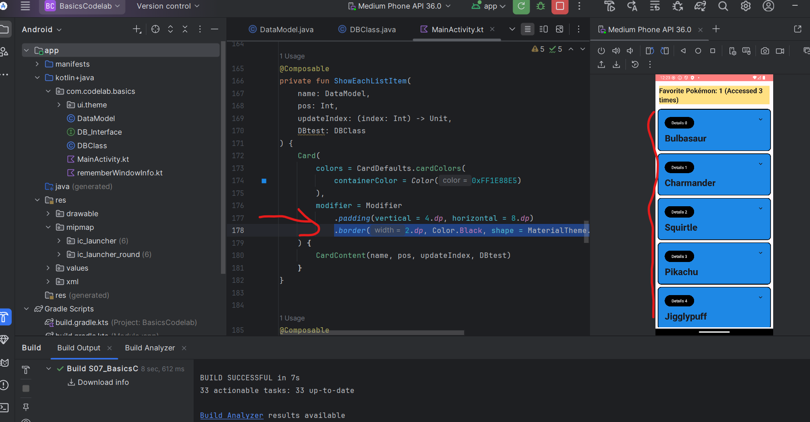

Change the description/details text style

Old Code:

if (expanded) {

Text(

text = (name.toString()) // Full toString of data

)

Log.d("CodeLab_DB", "Expanded name = ${name.toString()} ")

}

To:

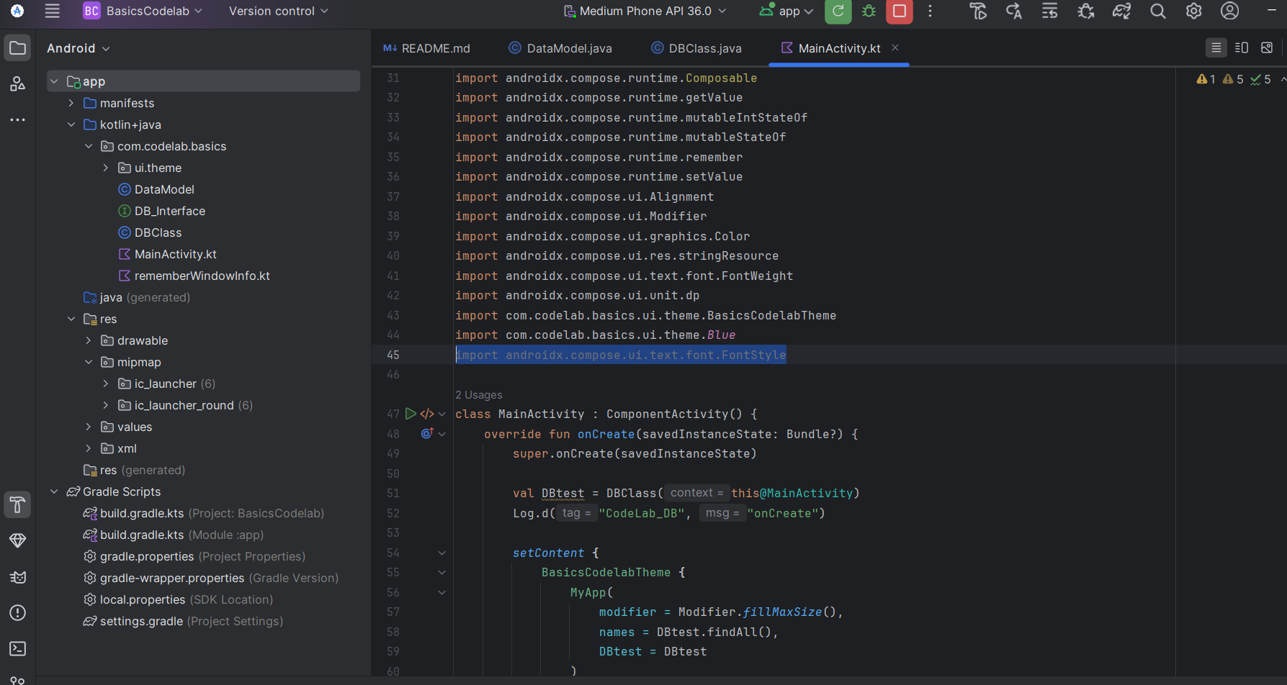

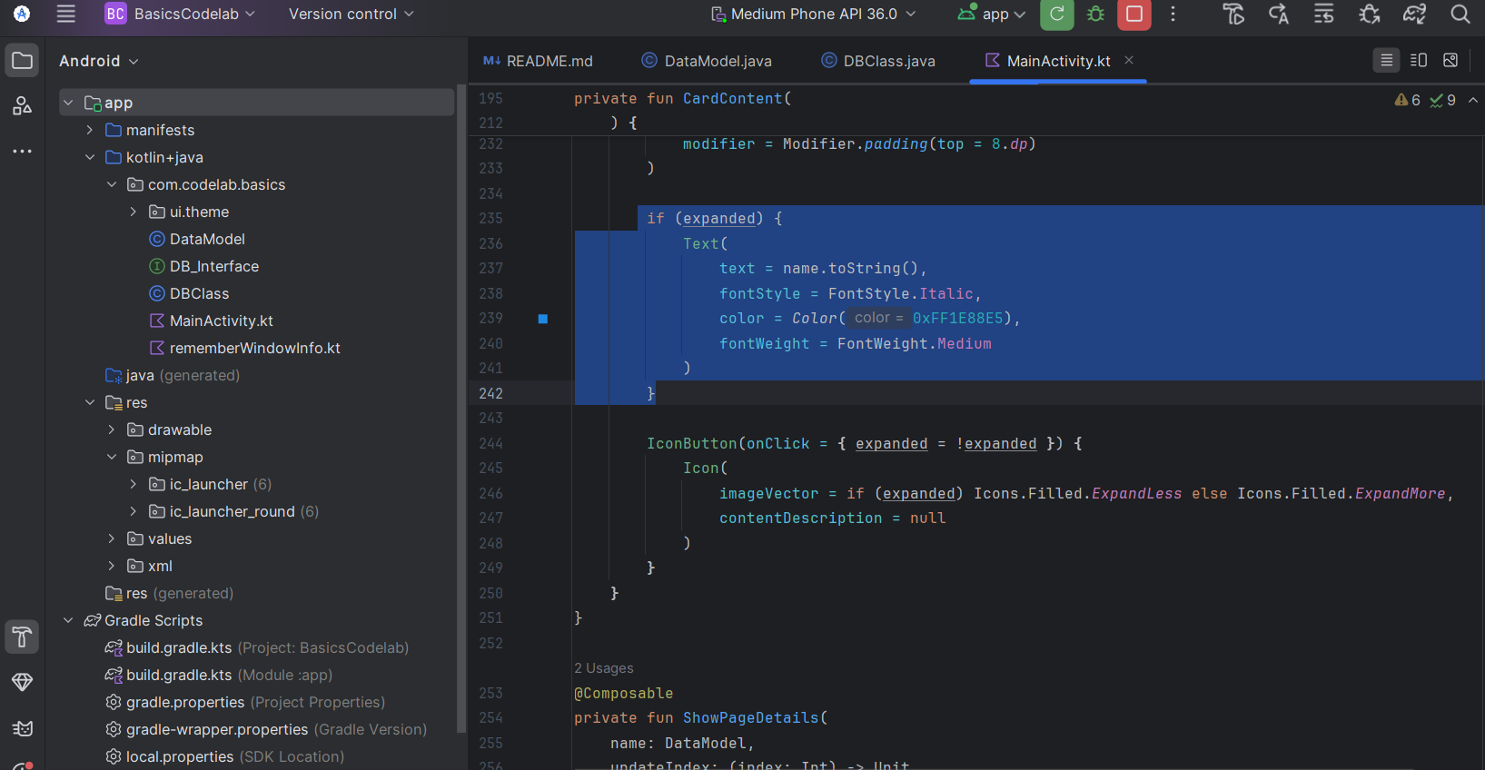

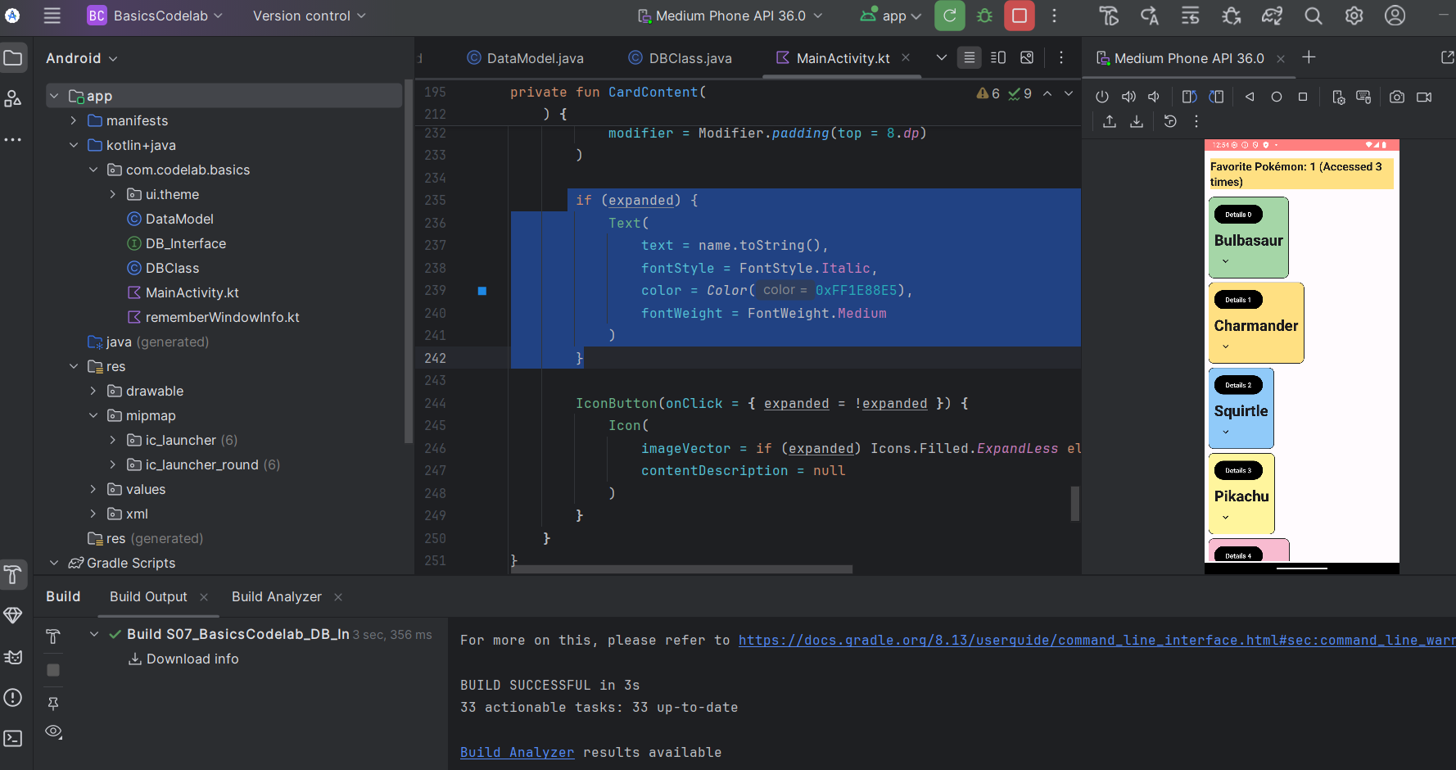

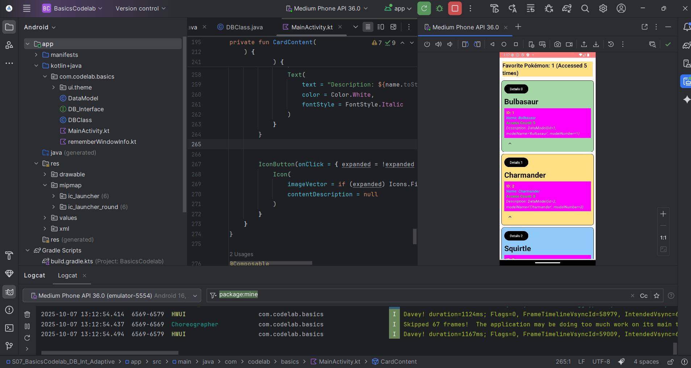

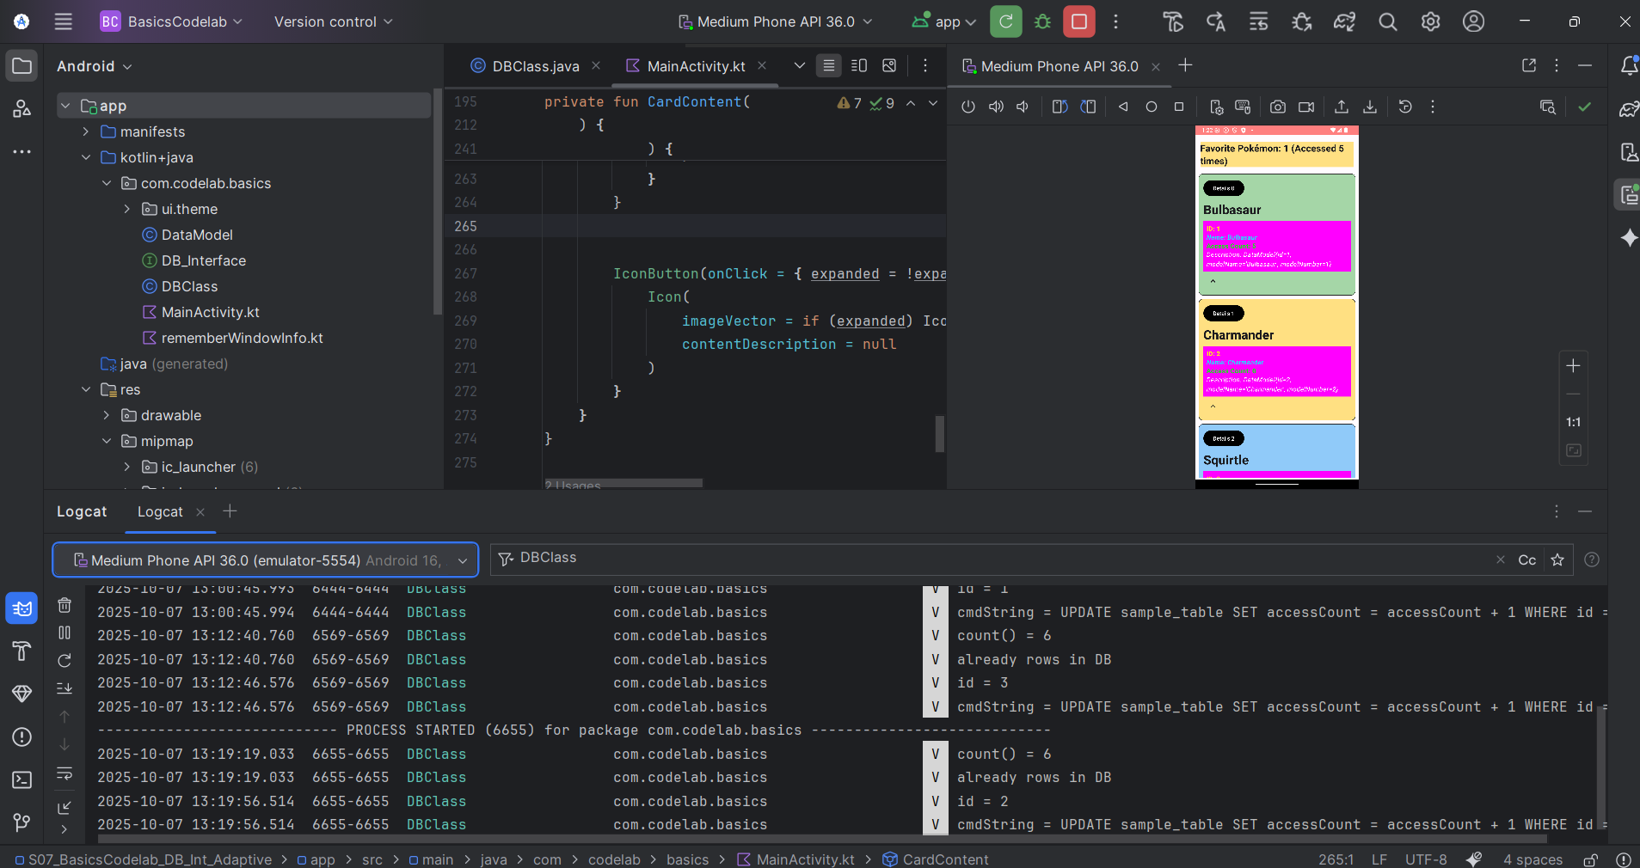

**Logcat Output:**

This screenshot shows that the app is working correctly and meets the assignment requirements. The database already has several Pokémon, and each time a user clicks the **details** button, the app updates the access count for that Pokémon. In Logcat, we can see messages showing which Pokémon was clicked and how many times it was accessed. On the emulator screen, the top yellow bar shows the Pokémon that has been selected the most, and the list below displays all Pokémon with their details. This proves that the database and the favorite Pokémon feature are connected and functioning together as expected.

Show running on 3 layouts:

Landscape: Medium Phone:

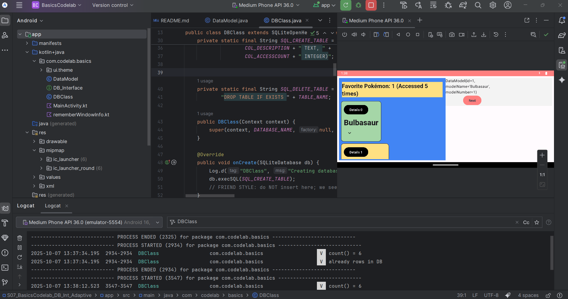

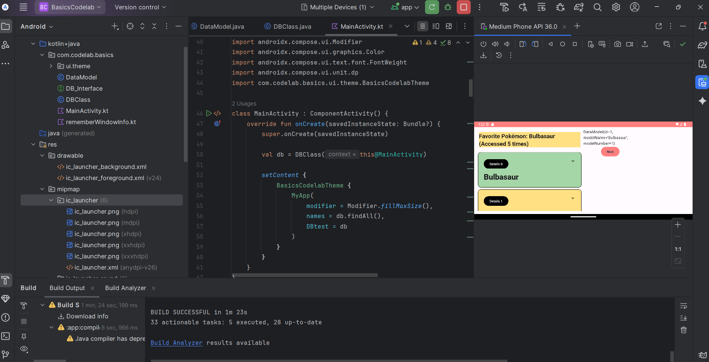

Pixel tablet:

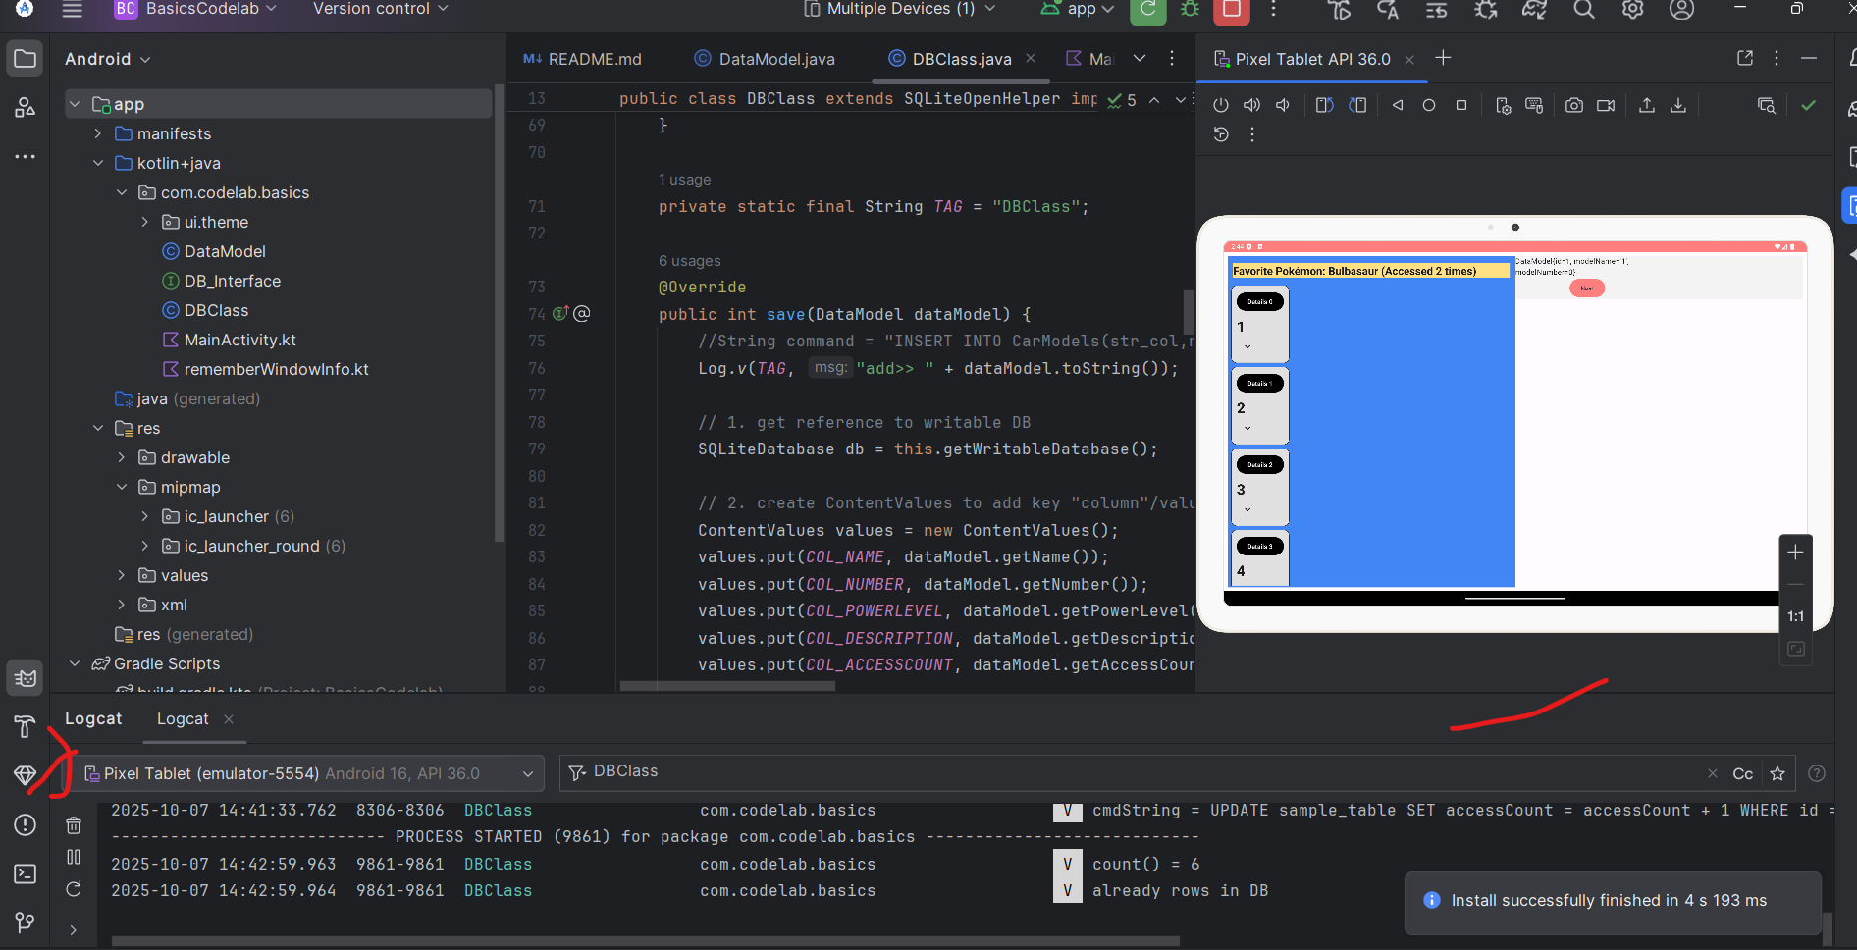

Television:

